**Cs-4513-001-Fall 2021, Dr. Le Gruenwald,**

**Naeem Shahabi Sani, 113526767,** [**shahabi@ou.edu**](mailto:shahabi@ou.edu)**,**

**INDIVIDUAL PROJECT: A JOB-SHOP ACCOUNTING SYSTEM**

**Tasks Performed Page Number**

Task 1. 1-10

1.1. ER Diagram 1-1

1.2. Relational Database Schema 2-10

Task 2. Data Dictionary

Task 3.

3.1. Discussion of storage structures for tables

3.2. Discussion of storage structures for tables (Azure SQL Database)

Task 4. SQL statements and screenshots showing the creation of

tables in Azure SQL Database

Task 5.

5,1 SQL statements **(and Transact SQL stored procedures, if any**)

Implementing all queries (1-15 and error checking)

5,2 The Java source program and screenshots showing

its successful compilation

Task 6. Java program Execution

6.1. Screenshots showing the testing of query 1

6.2. Screenshots showing the testing of query 2

6.3. Screenshots showing the testing of query 3

6.4. Screenshots showing the testing of query 4

6.5. Screenshots showing the testing of query 5

6.6. Screenshots showing the testing of query 6

6.7. Screenshots showing the testing of query 7

6.8. Screenshots showing the testing of query 8

6.9. Screenshots showing the testing of query 9

6.10. Screenshots showing the testing of query 10

6.11. Screenshots showing the testing of query 11

6.12. Screenshots showing the testing of query 12

6.13. Screenshots showing the testing of query 13

6.14. Screenshots showing the testing of query 14

6.15. Screenshots showing the testing of query 15

6.16. Screenshots showing the testing of the import and

export options

6.17. Screenshots showing the testing of three types of errors

6.18. Screenshots showing the testing of the quit option

Task 7. Web database application and its execution

7.1. Web database application source program and screenshots showing

Its successful compilation

7.2. Screenshots showing the testing of the Web database application 9

**Task 1.**

**ER Diagram**

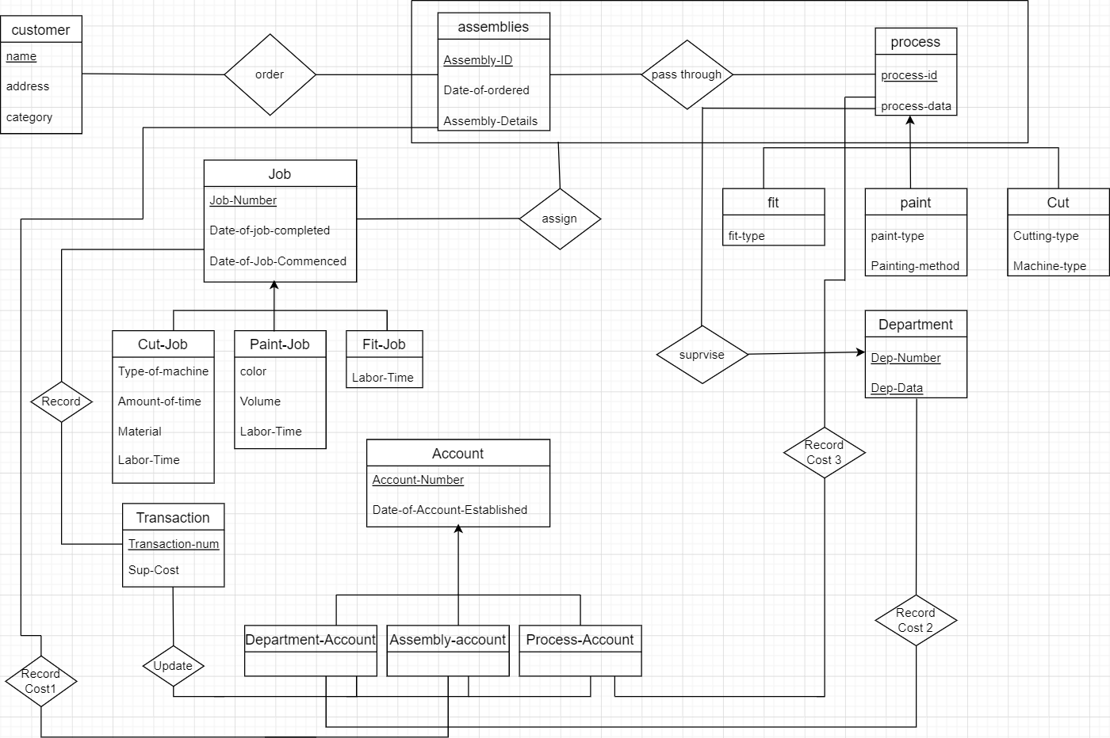

**Task 1.2. Relational Database Schema**

Customer (name ,address ,categ

Contents

**No table of contents entries found.**

ory)

Assembly (Assembly-id ,date-of-ordered ,Assembly-details)

Process (Process-Id ,Process-data)

Order (Assembly-id ,cname)

Fit (Process-Id ,Fit-type)

Paint (Process-Id ,paint-type ,Painting-method)

Cut (process-Id, Cutting-type ,Machine-type)

Job (Job-number ,Date-of-job-commenced ,Date-of-job-completed)

Cut-job (Job-number , type-of-machine ,amount-of-time ,material ,labor-time )

Paintjob (job-number , color, volume ,labor-time)

Fitjob (Job-number ,labor-time)

Account (Account-number ,date-of-account-established)

Department-account (Account-number)

Assembly-account (Account-number)

Process-account (account-number)

Transaction (Transaction-num, sup-cost)

Department (Dep-num, Dep-data)

Assign(Assembly-id, process-Id, job-number)

Pass-through(Assembly-id, process-Id)

Record(transaction-num, job-number)

Record cost 3(Account-number, process-Id)

Record cost 2 (Account-number, dep-number)

Record cost 1 (Account-number, Assembly-id)

Supervise (process-Id, Dep-number, Dep-data)

Update (transaction-num, Account-Number)

Task 2. Data Dictionary

<Customer>

|  |  |  |  |
| --- | --- | --- | --- |
| Field Name | Data Type | Size (Byte) | Constraints |
| Name | Varchar | 32 Byte | Primary Key |
| Address | Varchar | 32 Byte |  |
| Category | Integer | 4 Byte | 1-10 |

<Assembly>

|  |  |  |  |
| --- | --- | --- | --- |
| Field Name | Data Type | Size (Byte) | Constraints |
| Assembly-ID | INT | 5 | Primary Key, Not Null |
| Date-Of-Ordered | Datetime | 8 |  |
| Assembly-Details | Varchar | 32 Byte |  |

<Assign>

|  |  |  |  |
| --- | --- | --- | --- |
| Field Name | Data Type | Size (Byte) | Constraints |
| Assembly-ID | INT | 5 | FK, Primary Key, Not Null |
| Process-ID | INT | 5 | FK, Primary Key, Not Null |
| Job number | INT | 5 | FK, Primary Key, Not Null |

<Pass-through>

|  |  |  |  |
| --- | --- | --- | --- |
| Field Name | Data Type | Size (Byte) | Constraints |
| Assembly-Id | INT | 5 | FK, Primary Key, not null |
| Process-ID | INT | 5 | FK, Primary Key, not null |

<Process>

|  |  |  |  |
| --- | --- | --- | --- |
| Field Name | Data Type | Size (Byte) | Constraints |
| Process-ID | INT | 5 | Primary Key, not null |
| Process-Data | Varchar | 32 |  |

<Order>

|  |  |  |  |
| --- | --- | --- | --- |
| Field Name | Data Type | Size (Byte) | Constraints |
| Assembly-Id | INT | 5 | FK, Primary Key, not null |
| CName | Varchar | 32 | FK, Primary Key, not null |

<Fit>

|  |  |  |  |
| --- | --- | --- | --- |
| Field Name | Data Type | Size (Byte) | Constraints |
| Process-Id | INT | 5 | FK, Primary Key, not null |
| Fit-Type | Varchar | 32 |  |

<Paint>

|  |  |  |  |
| --- | --- | --- | --- |
| Field Name | Data Type | Size (Byte) | Constraints |
| Process-Id | INT | 5 | FK, Primary Key, Not null |
| Paint Type | Varchar | 32 |  |
| Painting-Method | Varchar | 32 |  |

<Cut>

|  |  |  |  |
| --- | --- | --- | --- |
| Field Name | Data Type | Size (Byte) | Constraints |
| Process- Id | INT | 5 | FK, Primary Key, Not null |
| Machine-Type | Varchar | 32 |  |
| Cutting-Type | Varchar | 32 |  |

<Job>

|  |  |  |  |
| --- | --- | --- | --- |
| Field Name | Data Type | Size (Byte) | Constraints |
| Job-Nom | INT | 5 | Primary Key, Not null |
| Date-Of-Job-Commenced | datetime | 8 |  |
| Date-Of-Job-Completed | datetime | 8 |  |

<Cut-Job>

|  |  |  |  |
| --- | --- | --- | --- |
| Field Name | Data Type | Size (Byte) | Constraints |
| Type-Of-Machine | Varchar | 32 |  |
| Amount-Of-Time | INT | 5 |  |
| Material | Varchar | 32 |  |
| Labor-Time | INT | 5 |  |
| Job-Number | INT | 5 | FK, Primary Key, Not null |

<Paint-Job>

|  |  |  |  |
| --- | --- | --- | --- |
| Field Name | Data Type | Size (Byte) | Constraints |
| Job-Number | INT | 5 | FK, Primary Key, Not null |
| Color | Varchar | 32 |  |
| Volume | Varchar | 32 |  |
| Labor-Time | INT | 5 |  |

<Fit-Job>

|  |  |  |  |
| --- | --- | --- | --- |
| Field Name | Data Type | Size (Byte) | Constraints |
| Job-Number | INT | 5 | FK, Primary Key, Not null |
| Labor-Time | INT | 5 |  |

<Account>

|  |  |  |  |
| --- | --- | --- | --- |
| Field Name | Data Type | Size (Byte) | Constraints |
| Account-Number | INT | 5 | Primary Key, Not null |
| Date-Of-Account-Established | Datetime | 8 |  |

<Department>

|  |  |  |  |
| --- | --- | --- | --- |
| Field Name | Data Type | Size (Byte) | Constraints |
| Dep-Number | INT | 5 | Primary Key, Not null |
| Dep-Data | Varchar | 32 | Primary Key, Not null |

<Department-Account>

|  |  |  |  |
| --- | --- | --- | --- |
| Field Name | Data Type | Size (Byte) | Constraints |
| Account-Number | INT | 5 | FK, Primary Key, Not null |

<Assembly-Account>

|  |  |  |  |
| --- | --- | --- | --- |
| Field Name | Data Type | Size (Byte) | Constraints |
| Account-Number | INT | 5 | Fk, Primary Key, Not null |

<Process-Account>

|  |  |  |  |
| --- | --- | --- | --- |
| Field Name | Data Type | Size (Byte) | Constraints |
| Account-Number | INT | 5 | FK, Primary Key, Not null |

<Transaction>

|  |  |  |  |
| --- | --- | --- | --- |
| Field Name | Data Type | Size (Byte) | Constraints |
| Transaction-Num | INT | 5 | Primary Key, Not null |
| Sup Cost | REAL | 5 |  |
|  |  |  |  |

<Record>

|  |  |  |  |
| --- | --- | --- | --- |
| Field Name | Data Type | Size (Byte) | Constraints |
| Transaction-Num | INT | 5 | FK, Primary Key, Not null |
| Sup Cost | REAL | 5 |  |

Record cost2

|  |  |  |  |
| --- | --- | --- | --- |
| Field Name | Data Type | Size (Byte) | Constraints |
| Account-Number | INT | 5 | FK, Primary Key, Not null |
| Dep-number | INT | 5 | FK, Primary Key, Not null |

Record Cost1

|  |  |  |  |
| --- | --- | --- | --- |
| Field Name | Data Type | Size (Byte) | Constraints |
| Account-Number | INT | 5 | FK, Primary Key, Not null |
| Assembly-id | INT | 5 | FK, Primary Key, Not null |

Record Cost3

|  |  |  |  |
| --- | --- | --- | --- |
| Field Name | Data Type | Size (Byte) | Constraints |
| Account-Number | INT | 5 | FK, Primary Key, Not null |
| Process-id | INT | 5 | FK, Primary Key, Not null |

Supervise

|  |  |  |  |
| --- | --- | --- | --- |
| Field Name | Data Type | Size (Byte) | Constraints |
| Process-Id | INT | 5 | FK, Primary Key, Not null |
| Dept Number | INT | 5 | FK, Primary Key, Not null |
| Dep- Data | Varchar | 32 | FK, Primary Key, Not null |

Update

|  |  |  |  |
| --- | --- | --- | --- |
| Field Name | Data Type | Size (Byte)c | Constraints |
| Transaction-num | INT | 5 | FK, Primary Key, Not null |
| Account number | INT | 5 | FK, Primary Key, Not null |

**Task 3.**

3.1. Discussion of storage structures for tables

|  |  |  |  |  |  |
| --- | --- | --- | --- | --- | --- |
| Table Name | Query# and Type | Search Key | Query Frequency | Selected File Organization | Justifications |
| customer | (1).insert  13. range search | category | 30/day  100/day | Index sequential  On search key  category | Because it is  Range search  We use index  sequential |
| Assembly | 4.insert |  | 40/day | Heap file | Because it is  insert |
| Record cost 3 | 5. insert |  | 10/day | Heap file | Because it is  insert |
| Assign | 6. insert |  | 50/day | Heap file | Because it is  insert |
| Record cost 1 | 5.insert |  | 10/day | Heap file | Because it is  insert |
| Process | 3.insert |  | infrequent | Heap file | Because it is  insert |
| Department | 3.insert |  | infrequent | Heap file | Because it is  insert |
| Order | 4.insert |  | 40/day | Heap file | Because it is  insert |
| Pass through | 4.enter  11. Retrieve | Process-id | 40/day  100/day | Dynamic hashing  With hash key  Process id | Because retrieve  Is like random  search |
| Account | 5.create |  | 10/day | Heap file | Because it is  insert |
| Record cost 2 | 5.create |  | 10/day | Heap file | Because it is  insert |
| Record cost 1 | 5.create |  | 10/day | Heap file | Because it is  insert |
| Job | 6.insert  12. Retrieve  12. Random search | Given date | 50/day  20/day  20/day | Heap file | Because it is  insert |
| Cut-job | 7.enter  14.Delete  14.range search | Job -no | 50/day  1/month  1/month | Heap file | Because it is  insert |
| Pain-job | 7.enter  14. change |  | 50/day  1/month | Heap file | Because it is  insert |
| Fit-job | 7.insert |  | 50/day | Heap file | Because it is  insert |
| Transaction | 8.insert |  | 50/day | Heap file | Because it is  insert |
| Record cost 1 | 9.Retrieve |  | 200/day | Dynamic hashing  With hash key  Assembly id or  Account number | Because retrieve  Is like random  search |

**3.2. Discussion of storage structures for tables (Azure SQL Database)**

Azure Storage is a Microsoft-managed cloud service that provides storage that is highly available, secure, durable, scalable and redundant. Whether it is images, audio, video, logs, configuration files, or sensor data from an IoT array, data needs to be stored in a way that can be easily accessible for analysis purposes, and Azure Storage provides options for each one of these possible use cases.

Within Azure there are two types of storage accounts, four types of storage, four levels of data redundancy and three tiers for storing files. We will explore each one of these options in detail to help you understand which offering meets your big data storage needs.

**Azure Storage Account Types**

An Azure storage account is an access point to all the elements that compose the Azure storage realm. Once the user creates the storage account, they can select the level of resilience needed and Azure will take care of the rest. A single storage account can store up to 500TB of data and like any other Azure service, users can take advantage of the pay-per-use pricing model.

There are two different storage account types. With the “standard” storage account, users get access to Blob Storage, Table Storage, Queue Storage and File Storage. The alternative, “premium” account, is the most recent storage option which provides users with data storage on SSD drives for better I/O performance; this option supports only page blobs.

Azure Blob Storage

Blob Storage is Microsoft Azure’s service for storing binary large objects or blobs which are typically composed of unstructured data such as text, images, and videos, along with their metadata. Blobs are stored in directory-like structures called “containers.”

The blob service includes:

* Blobs, which are the data objects of any type
* Containers, which wrap multiple blobs together
* Azure storage account, which contains all of your Azure storage data objects

Blob Storage Categories

Although blob allows for storage of large binary objects in Azure, these are optimized for three different storage scenarios:

* Block blobs: These are blobs that are intended to store discrete objects such as images, log files and more. Block blobs can store data up to ~5TB, or 50,000 blocks of up to 100MB each.
* Page blobs: These are optimized for random read and write operations and can grow up to 8TB in size. Within the page blob category, Azure offers two types of storage: standard and premium. The latter is the most ideal for virtual machine (VM) storage disks (including the operating system disk).
* Append Blobs: Optimized for append scenarios like log storage, append blogs are composed of several blocks of different sizes — up to a maximum of 4MB. Each append blob can hold up to 50,000 blocks, therefore allowing each append blob to grow up to 200GB.

Blob storage accounts offer three types of tiers that are selected at the time of creation of the storage account.

* Hot Access Tier: Out of the three options, the hot access tier is the most optimized for data that is accessed frequently. It offers the lowest access (read-write) cost, but the highest storage cost.
* Cool Access Tier: This option is better suited for use cases where data will remain stored for at least 30 days and is not accessed frequently. Compared to hot access tiers, this tier offers lower storage costs and higher access costs.
* Archive Access Tier: Archive storage is designed for data that doesn’t need to be accessed immediately. This tier offers higher data retrieval costs, and also higher data access latency. It is designed for use cases where data will be stored for more than 180 days and is rarely accessed.

Why Use Blob Storage?

Much of what data consumers do with storage is focused on dealing with unstructured data such as logs, files, images, videos, etc. Using Azure’s blob storage is a way to overcome the challenge of having to deploy different database systems for different types of data. Blob storage provides users with strong data consistency, storage and access flexibility that adapts to the user’s needs, and it also provides high availability by implementing geo-replication.

**Azure Table Storage**

Azure Table Storage is a scalable, NoSQL, key-value data storage system that can be used to store large amounts of data in the cloud. This storage offering has a schema less design, and each table has rows that are composed of key-value pairs. Microsoft describes it as an ideal solution for storing structured and non-relational data, covering use cases ranging from storing terabytes of structured data that serves web applications, to storing datasets that do not require complex joins or foreign keys, to accessing data using .NET libraries.

**Azure Table Storage Components**

Table storage includes:

* A storage account, which contains all your tables.
* Tables, which are composed of collections of “entities.”
* Entities, which are sets of properties, similar to database rows. An entity can grow to up to 1MB in size.
* Properties, the most granular element in the list, are composed of name-value pairs. Entities can wrap up to 252 properties to store data, and each entity contains three system properties that define its partition key, row key and timestamp.

Because Azure Storage tables are represented in a tabular format, they can be easily confused with RDBMS tables. However, Azure tables don’t have the notion of columns, constraints or 1:1 or 1:* relationships and any of their variations.

**Azure Table Storage vs. Azure SQL Database**

These two technologies, while very similar, are designed to tackle very different use cases. However, one of the main differences between the two is their capacity. Azure tables can have rows of up to 1MB in size with no more than 255 properties including the three identifying keys: partition, row and timestamp. Meaning, that when users add the size of all 255 properties, they can’t exceed 1MB.

On the other side, Azure SQL databases can have rows up to 2GB in size. Naturally, this would make the user think that Azure SQL databases are a no-brainer when it comes to storing large amounts of data. However, Azure SQL databases can scale up to 150GB only, while the maximum data size for Azure tables is 200TB per table.

**Azure Queue Storage**

Queues have been around for a long time — their simple FIFO (first in, first out) architecture makes queues a versatile solution for storing messages that do not need to be in a certain order. In simple terms, Azure Queue Storage is a service that allows users to store high volumes of messages, process them asynchronously and consume them when needed while keeping costs down by leveraging a pay-per-use pricing model.

**Azure Storage Queues Components**

Queue storage is composed of the following elements:

**Storage Account**, which contains all your storage services.

**Queue**, composed of a set of messages.

**Message**, includes any kind of information. For example, a message could be a text message that is supposed to trigger an event on an app, or information about an event that has happened on a website. A message, in any format, can only be up to 64KB in size and the maximum time that a message can remain in a queue is seven days.

However, a single queue can hold up to 200TB worth of messages. Messages can be text strings or arrays of bytes containing any kind of information in formats such as XML, CSV, etc.

**Azure File Storage**

Azure Files is a shared network file storage service that provides administrators a way to access native SMB file shares in the cloud. These shares — as well as the rest of the Azure storage offerings — can be set as part of the Azure storage account. The Azure File service provides a way for applications running on cloud VMs to share files among them by using standard protocols like WriteFile or ReadFile.

**Reference (https://www.dremio.com/data-lake/adls/)**

**Task 4.**

CREATE TABLE process()

processId int,

processData VARCHAR(32),

PRIMARY key (processId)

);

CREATE TABLE fit (

fittype varchar(32),

processId int,

primary key (processId),

foreign KEY (processId) references process(processId)

);

CREATE TABLE paint (

painttype varchar(32),

paintingmethod varchar(32),

processId INT,

primary key (processId),

foreign KEY (processId) references process(processId)

);

CREATE TABLE cut (

cuttingtype varchar(32),

machinetype varchar(32),

processId INT,

primary key (processId),

foreign KEY (processId) references process(processId)

);

create table Job(

jobNomber int,

dateofjobcommenced int,

dateofjobcompleted int,

primary key(jobNomber)

);

create table fitjob(

jobNomber int,

labortime int,

primary key(jobNomber),

foreign key (jobNomber) references Job(jobNomber)

);

create table painjob(

jobNomber int,

labortime int,

color varchar(15),

amountoftime int,

primary key(jobNomber),

foreign key (jobNomber) references Job(jobNomber)

);

create table cutjob(

jobNomber int,

labortime int,

color varchar(15),

amountoftime int,

typeofmachine varchar(32),

primary key(jobNomber),

foreign key (jobNomber) references Job(jobNomber)

);

CREATE TABLE passthrugh(

Assemblyid int,

processId int,

PRIMARY key(Assemblyid, processId),

FOREIGN KEY (Assemblyid) REFERENCES Assembly(Assemblyid),

FOREIGN KEY (processId) REFERENCES process(processId)

);

CREATE TABLE account (

accountnumber int,

dateofaccount int,

primary key (accountnumber)

);

create TABLE departmentaccount(

accountnumber INT,

sup_cost REAL,

PRIMARY KEY(accountnumber)

FOREIGN KEY(accountnumber) REFERENCES account(accountnumber)

);

create TABLE assemblyaccount(

accountnumber INT,

sup_cost REAL,

PRIMARY KEY(accountnumber),

FOREIGN KEY(accountnumber) REFERENCES account(accountnumber)

);

create TABLE processaccount(

accountnumber INT,

sup_cost REAL,

PRIMARY KEY(accountnumber),

FOREIGN KEY(accountnumber) REFERENCES account(accountnumber)

);

CREATE TABLE Transaction1(

transactionnumber ,

sup_cost REAL,

PRIMARY KEY(transactionnumber)

);

CREATE TABLE Assembly (

Assemblyid int,

address varchar(32),

dateofordered INT,

AssemblyDeatails varchar(80),

primary key(Assemblyid)

);

CREATE TABLE assign(

Assemblyid int,

processId int,

jobnomber INT

PRIMARY key(Assemblyid, processId, jobnomber),

FOREIGN KEY (Assemblyid) REFERENCES Assembly(Assemblyid),

FOREIGN KEY (processId) REFERENCES process(processId),

FOREIGN KEY (jobnomber) REFERENCES Job(jobnomber)

);

CREATE TABLE record(

transactionnumber int,

jobnomber INT

PRIMARY key(transactionnumber, jobnomber)

);

CREATE TABLE order1(

Assemblyid int,

cname int,

PRIMARY key(Assemblyid, cname),

FOREIGN KEY (cname) REFERENCES customer(cname),

FOREIGN KEY (Assemblyid) REFERENCES Assembly(Assemblyid)

);

CREATE TABLE department(

departmentnumber int,

departmentdata VARCHAR(70),

PRIMARY KEY(departmentnumber,departmentdata),

);

CREATE TABLE supervise(

processId int,

departmentnumber int,

departmentdata VARCHAR(32),

PRIMARY key(processId, departmentnumber, departmentdata),

FOREIGN KEY (processId) REFERENCES process(processId),

FOREIGN KEY (departmentnumber) REFERENCES department(departmentnumber),

);

create table record_dept_cost(

account_num INT,

dept_num INT,

PRIMARY KEY(account_num, dept_num),

FOREIGN KEY(account_num) REFERENCES departmentaccount(accountnumber),

FOREIGN KEY(dept_num) REFERENCES department(departmentnumber),

);

create table record_assembly_cost(

account_num INT,

assembly_id INT,

PRIMARY KEY(account_num, assembly_id),

FOREIGN KEY(account_num) REFERENCES assemblyaccount(accountnumber),

FOREIGN KEY(assembly_id) REFERENCES assembly(Assemblyid),

);

create table record_process_cost(

account_num INT,

process_id INT,

PRIMARY KEY(account_num, process_id),

FOREIGN KEY(account_num) REFERENCES processaccount(accountnumber),

FOREIGN KEY(process_id) REFERENCES process(processId),

);

create table record_cost(

account_num INT,

process_id INT,

PRIMARY KEY(account_num, process_id),

FOREIGN KEY(account_num) REFERENCES account(accountnumber),

FOREIGN KEY(process_id) REFERENCES process(processId)

);

CREATE TABLE customer(

cname int,

caddress VARCHAR(32),

category INT,

PRIMARY KEY(cname),

CONSTRAINT CHK_category CHECK (category IN ('1','2','3','4','5','6','7','8','9','10'))

);

CREATE TABLE update1(

transactionnumber INT,

FOREIGN KEY (transactionnumber) REFERENCES transaction1(transactionnumber),

FOREIGN KEY (accountnumber) REFERENCES account(accountnumber)

);

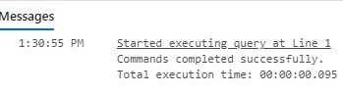

**Task 5.1**

**(Attention: I talked to the TA (Taras Basiuk) and he said that showing the implementation of the queries in the Java program is enough for this exercise. And it does not need to be implemented in azure SQL. However, I implemented most of the queries in SQL, but the full version is at the end of this section, which was implemented in Java.)**

**Query 1.**

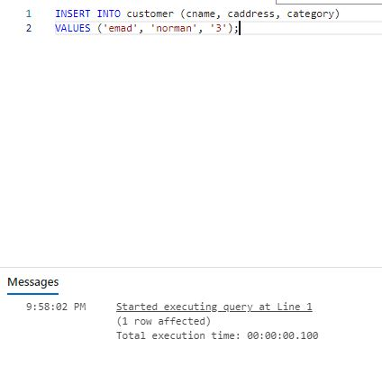

**Query 2.**

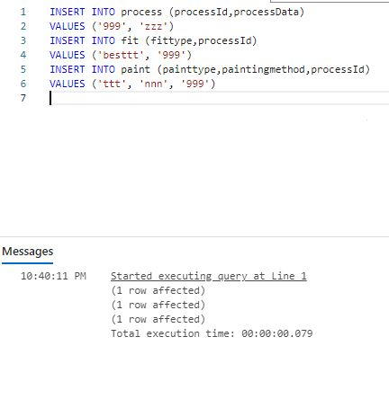

**Query 3.**

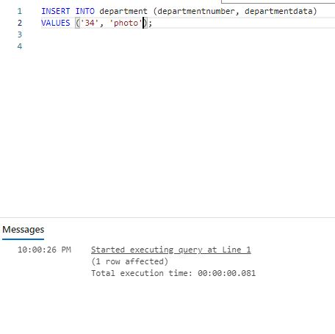

**Query 4.**

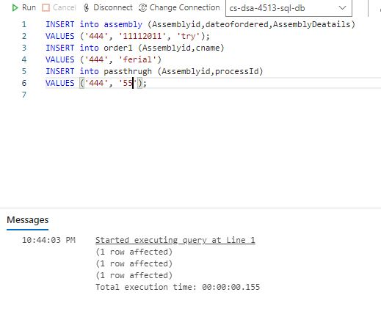

**Query 6.**

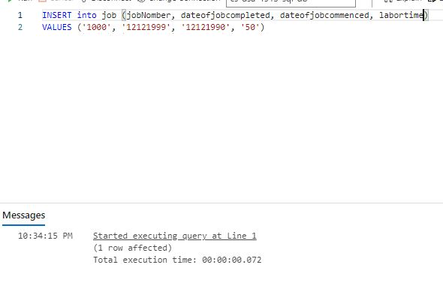

**Query 10.**

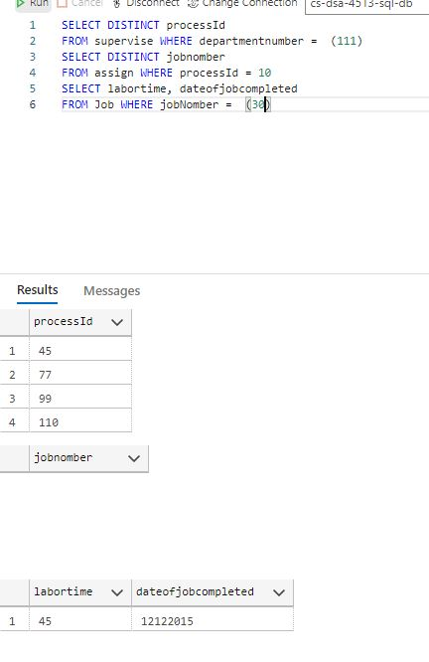

**Query 11.**

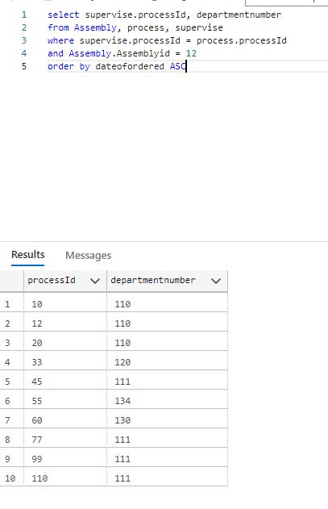

**Query 12.**

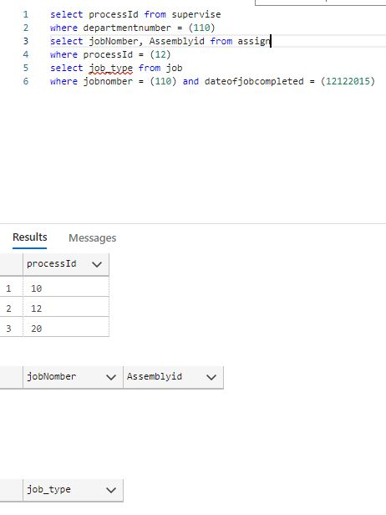

**Query 13.**

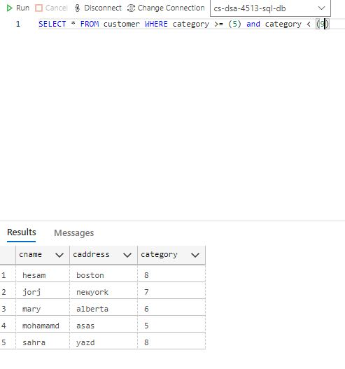

**Query 14.**

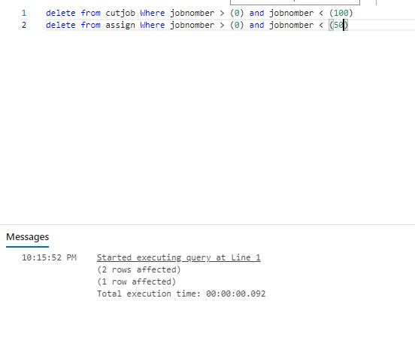

**Query 15.**

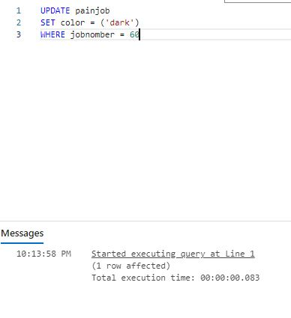

**All Queries in Java.**

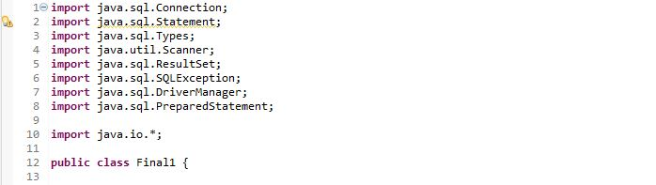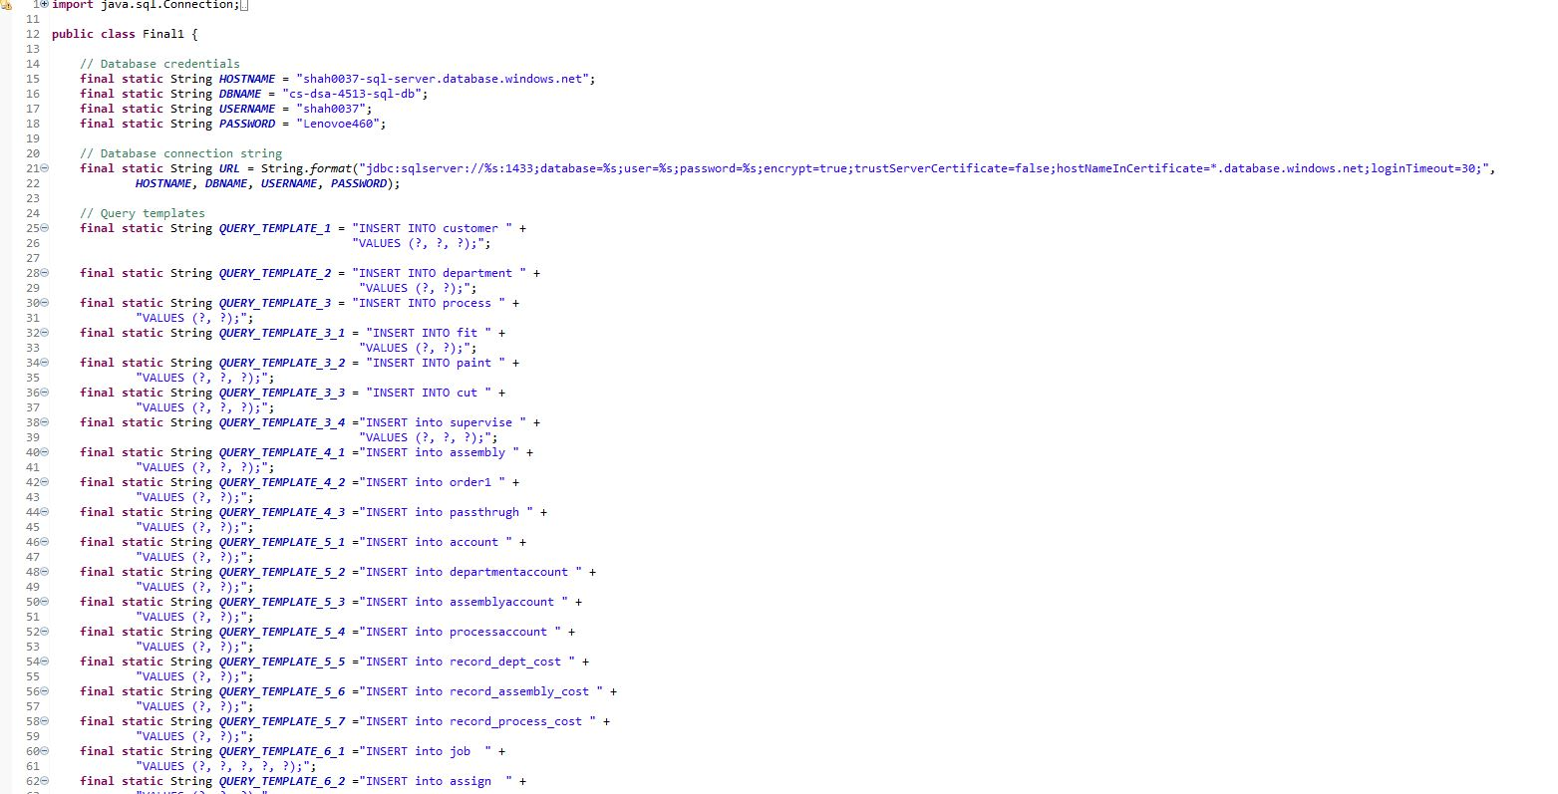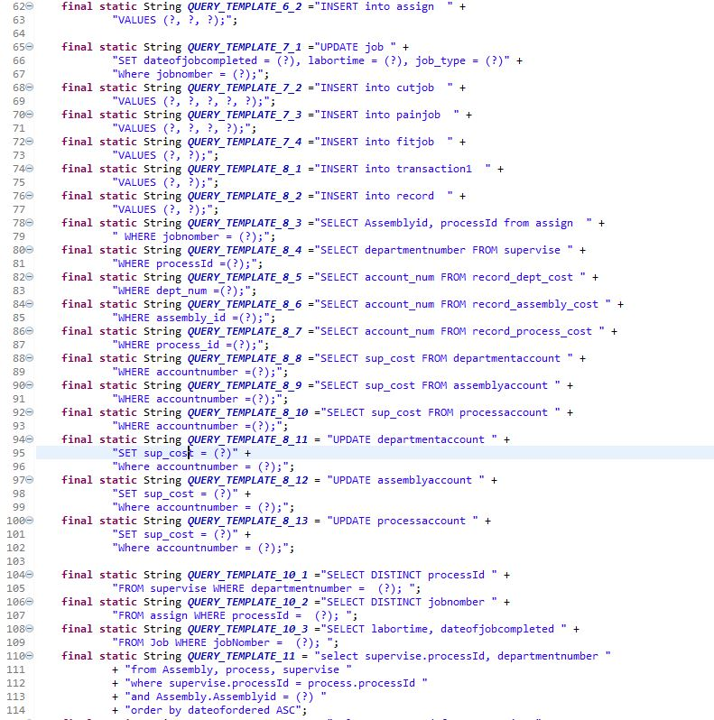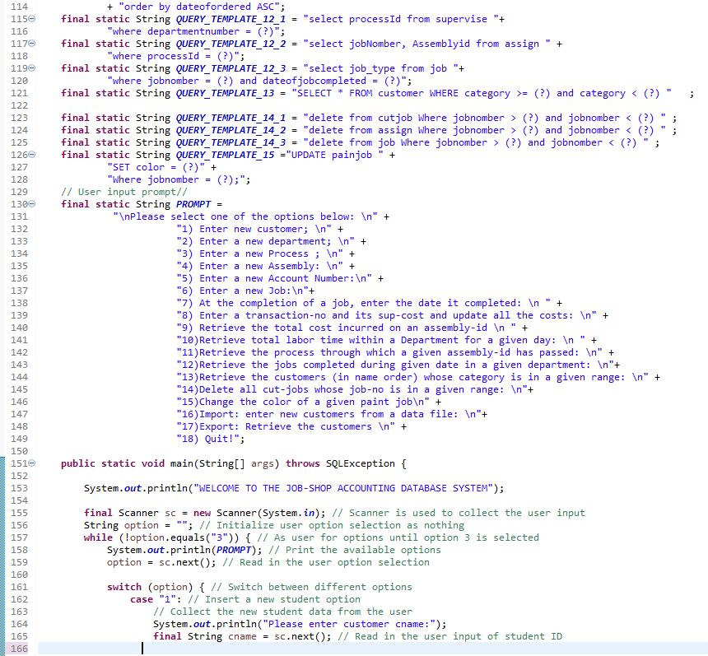

**Task 5.2:**

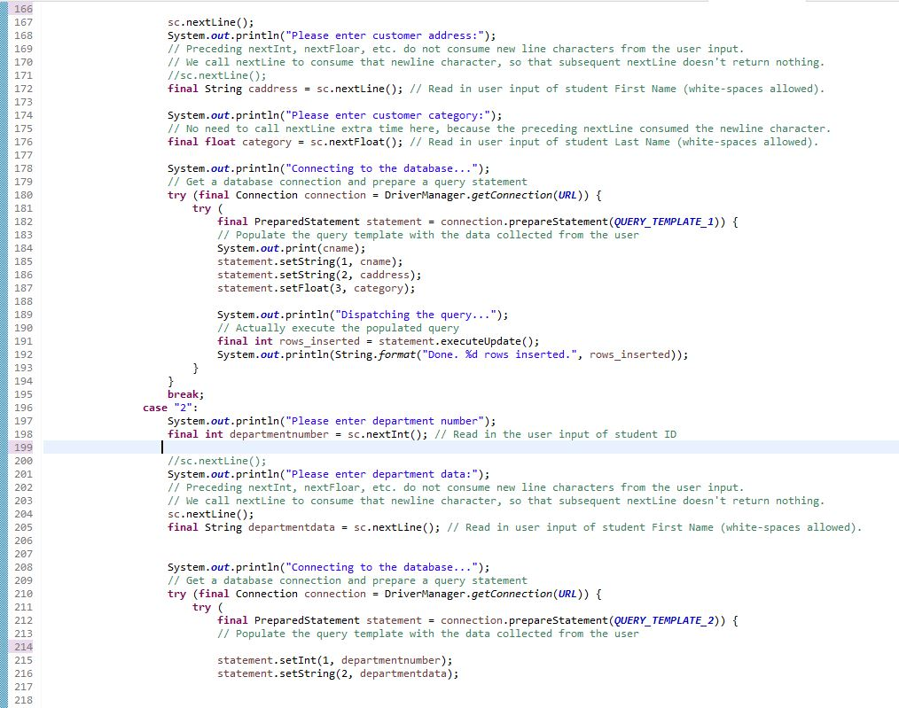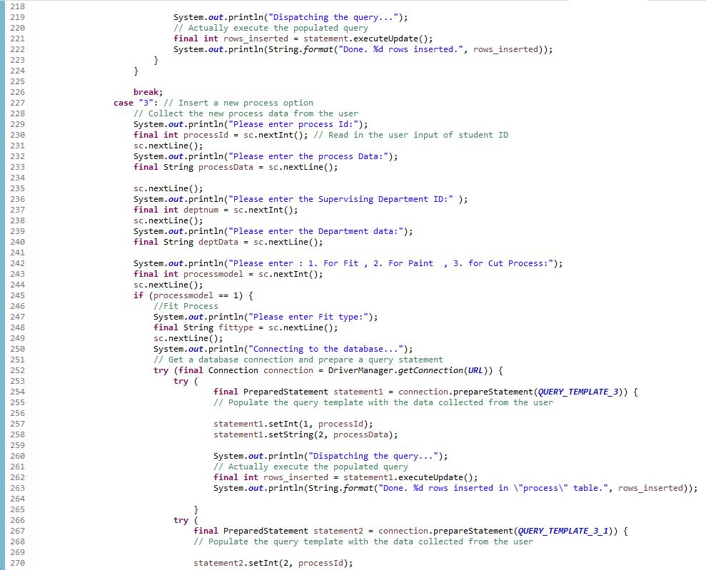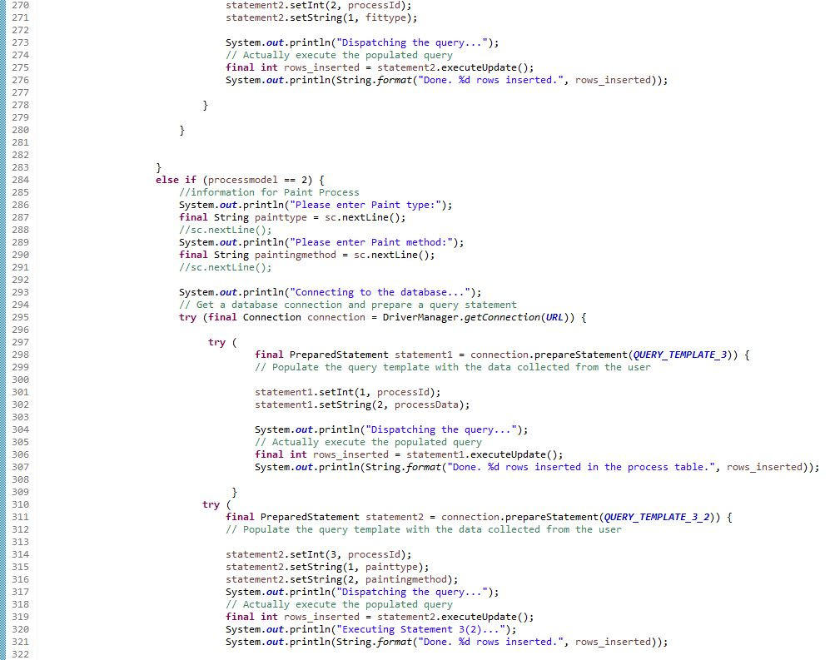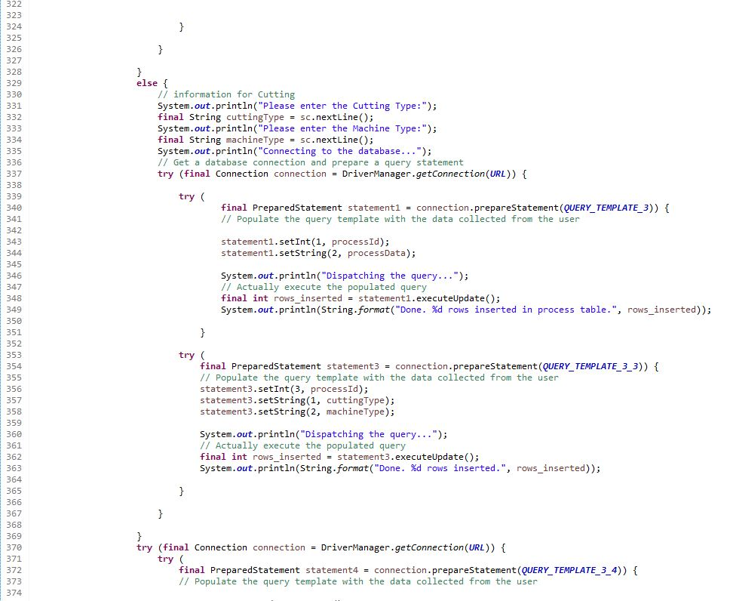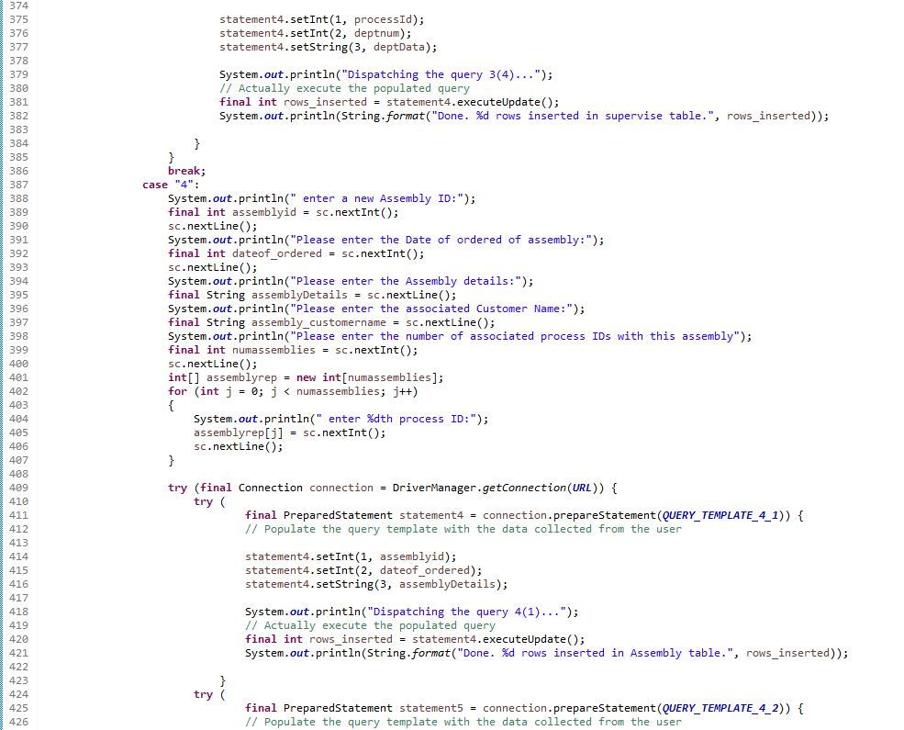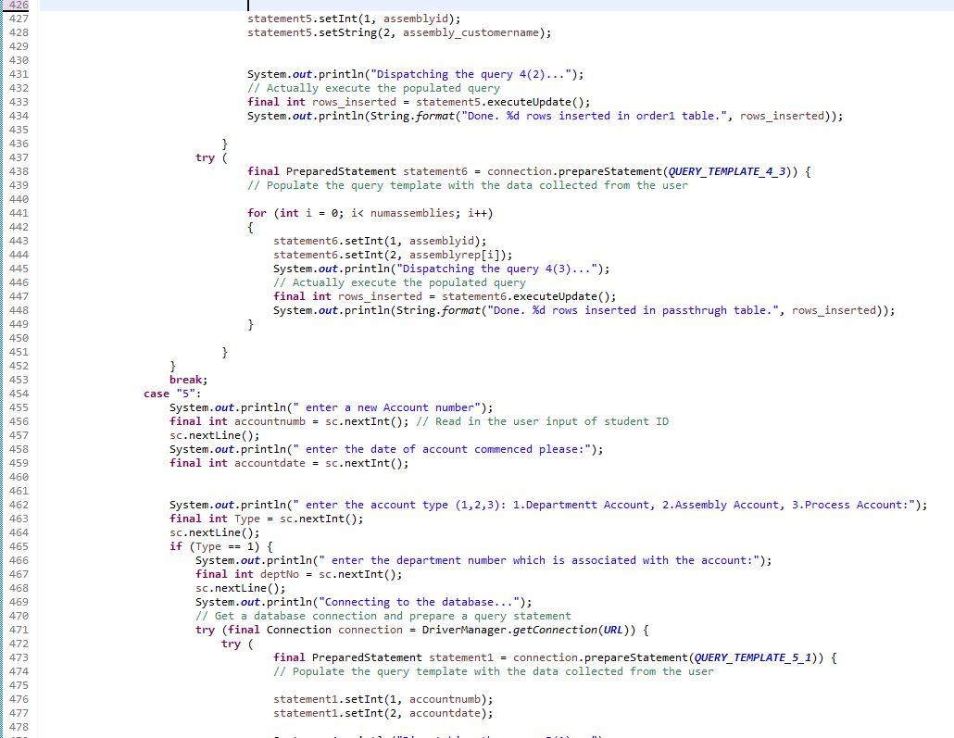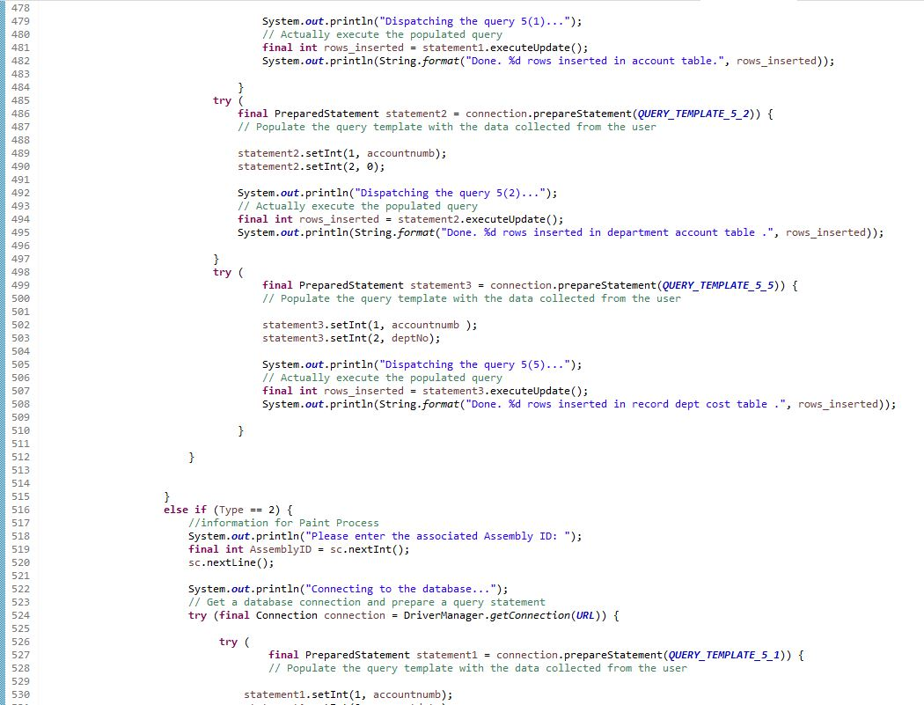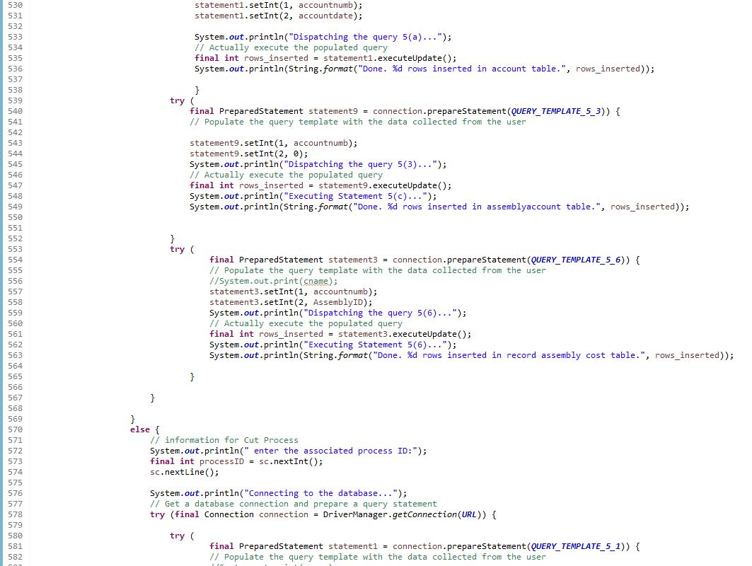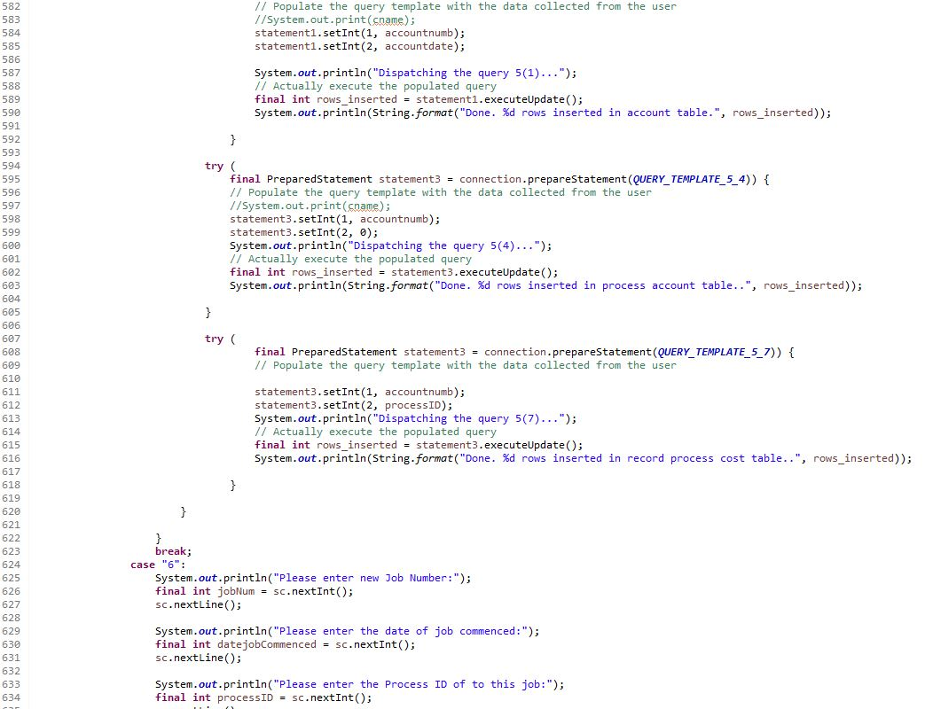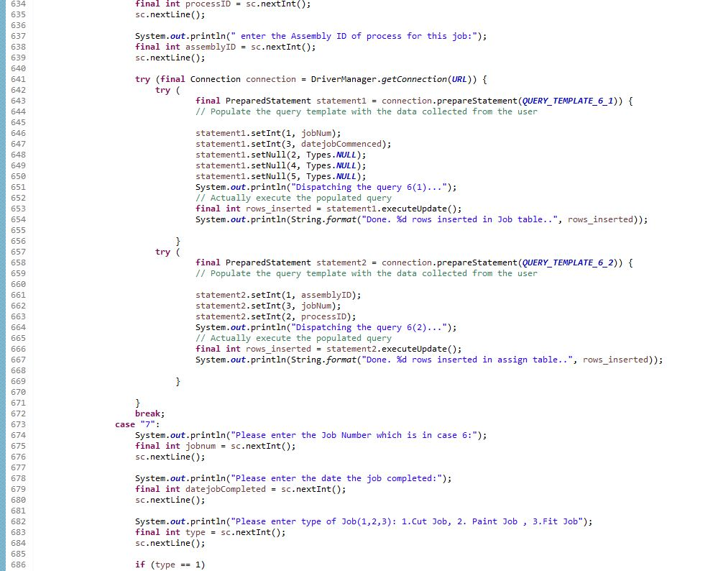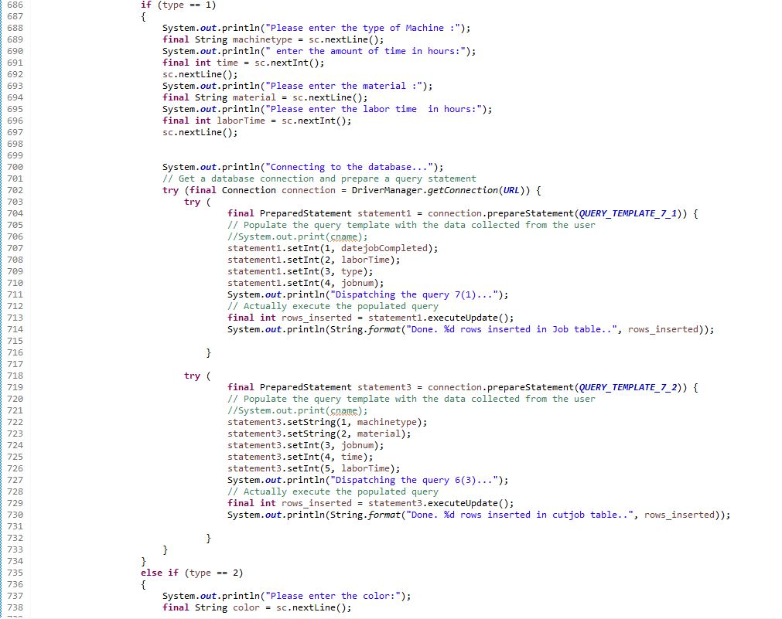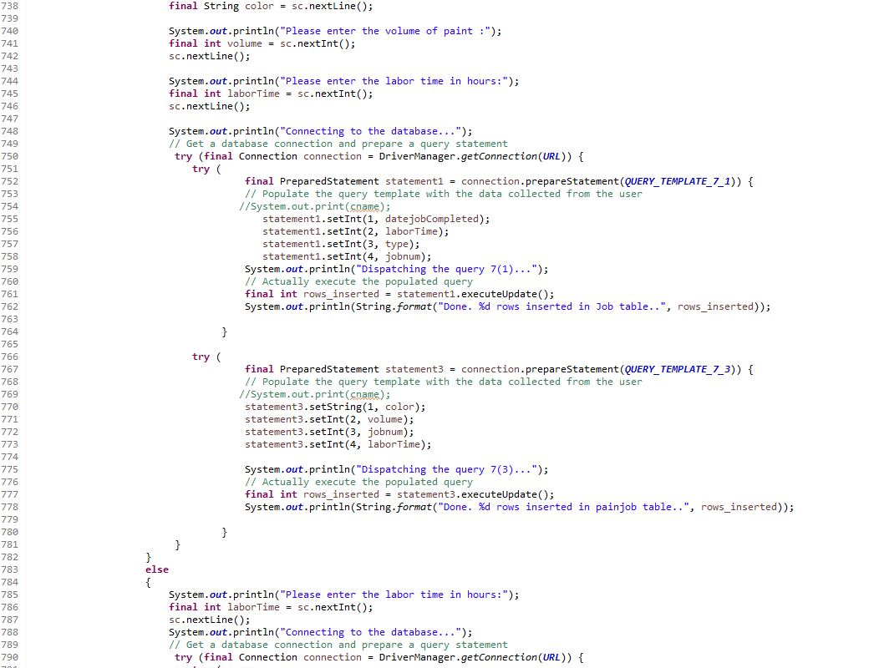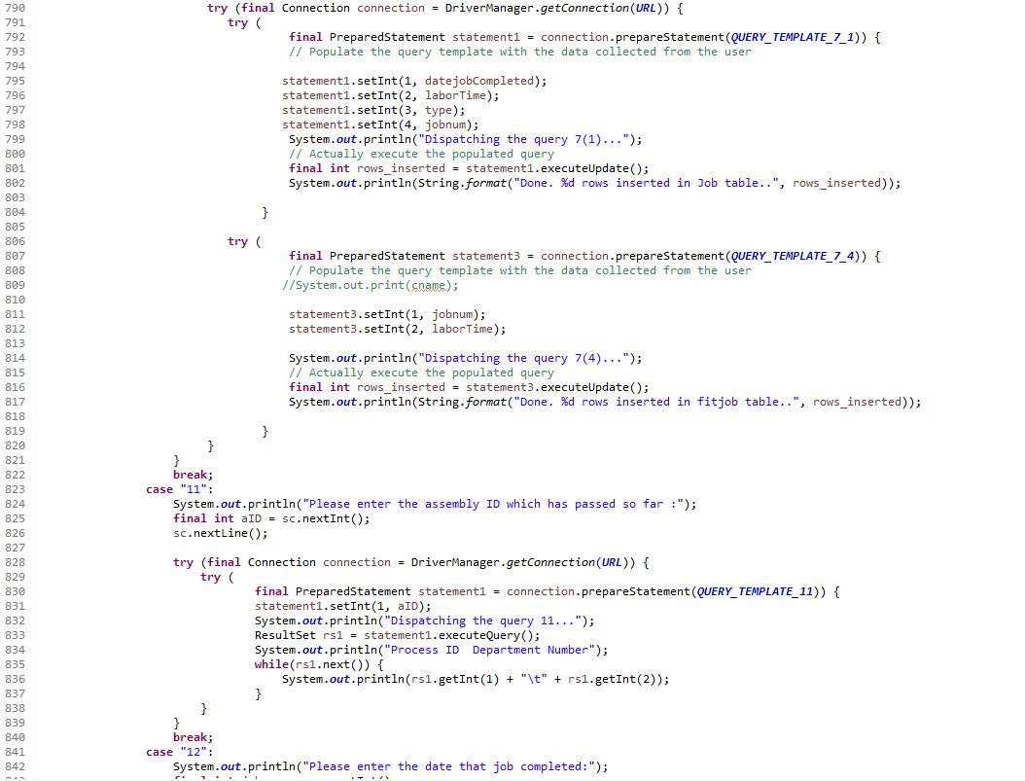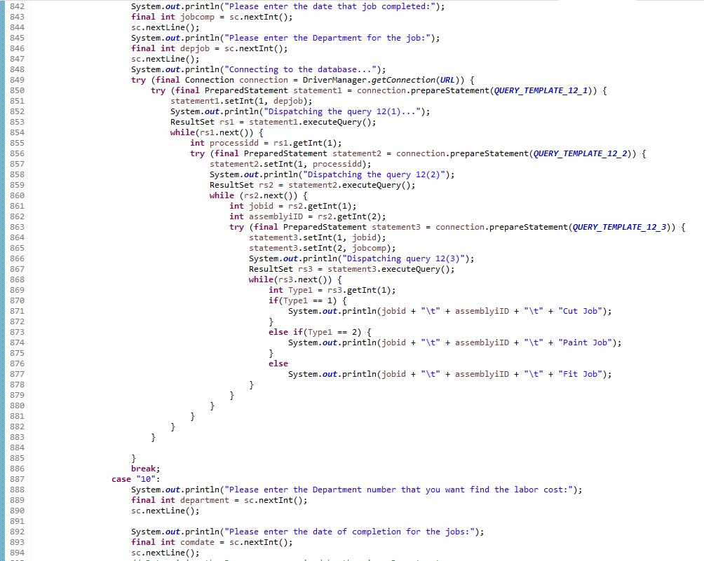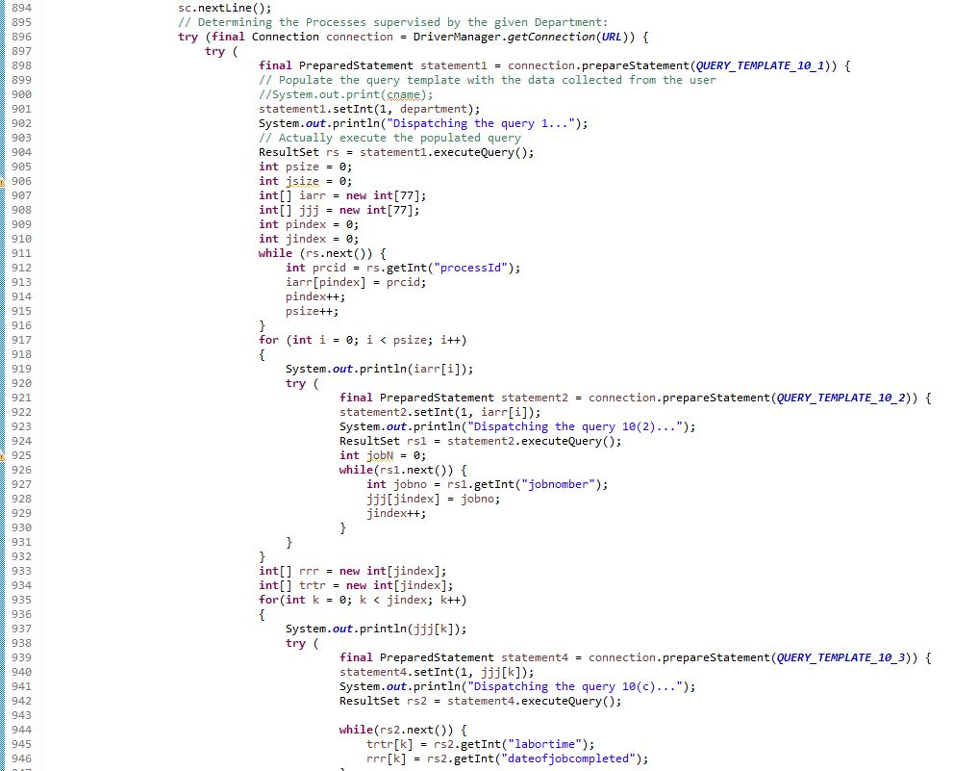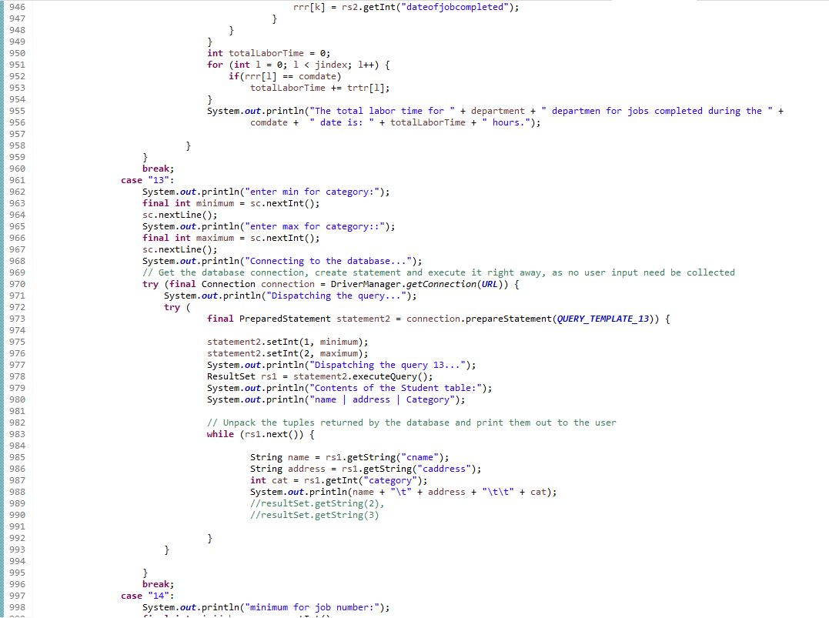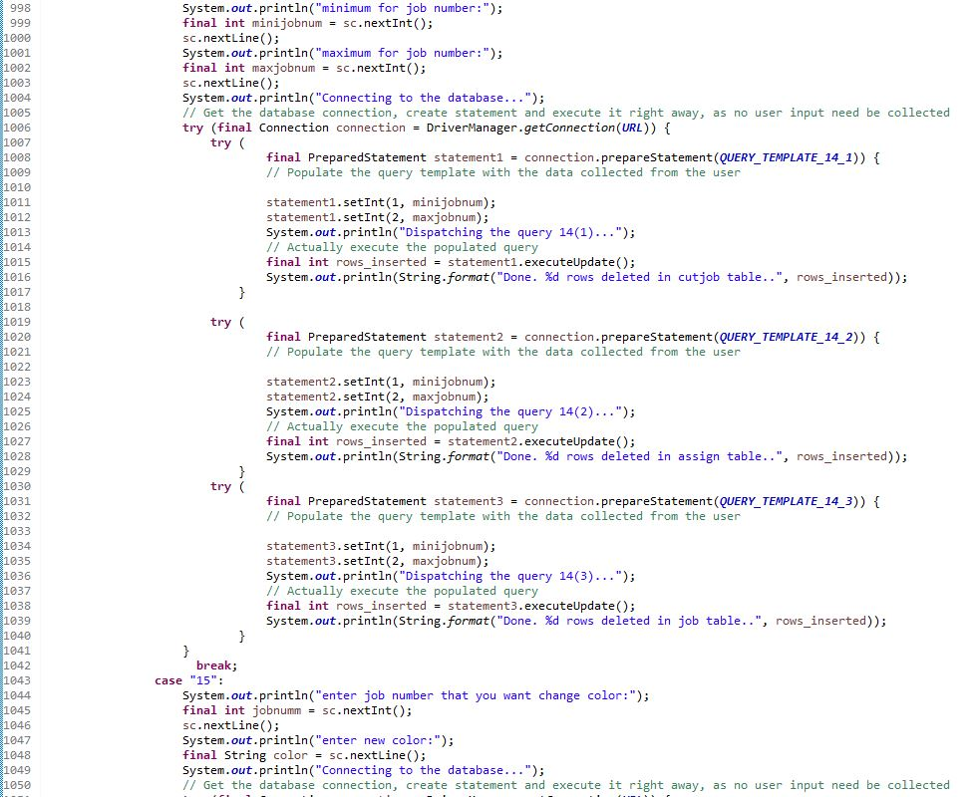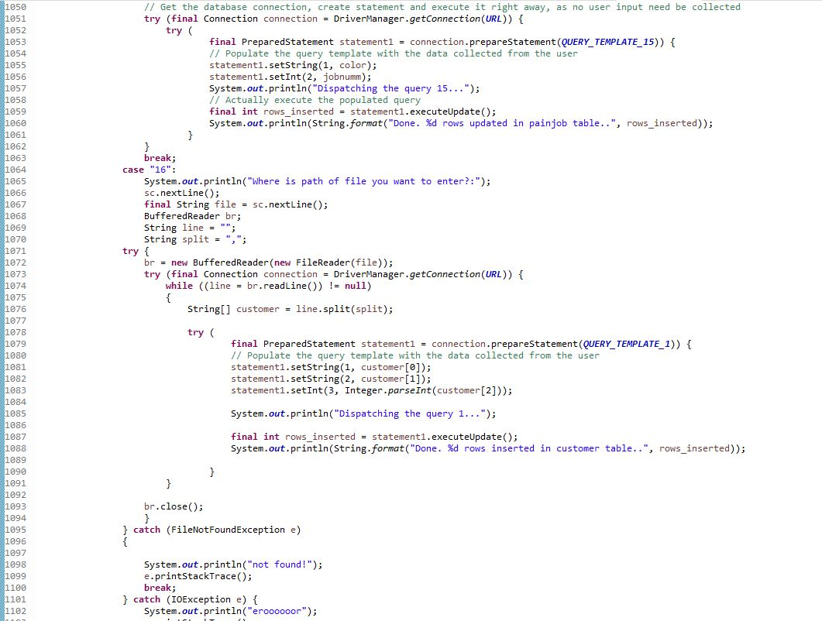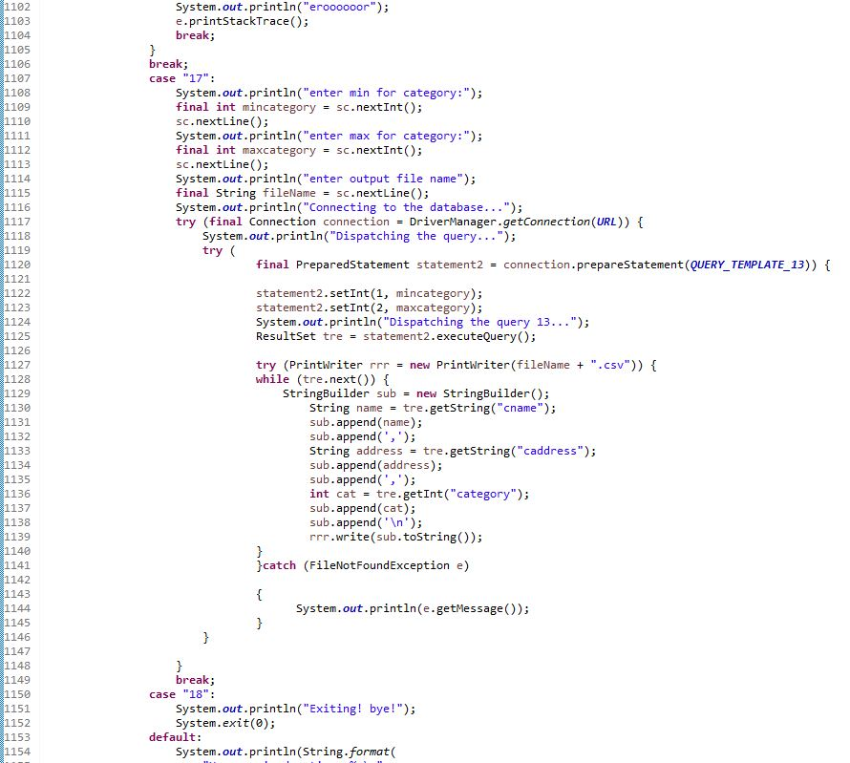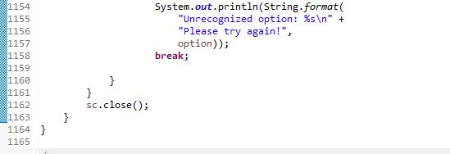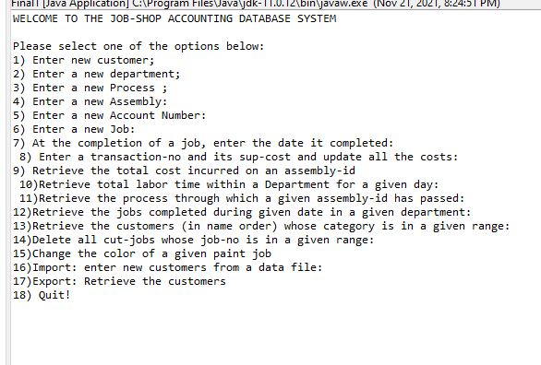

**Task 6**. Run the program created for Tasks 5 to test its correctness.

6.1.

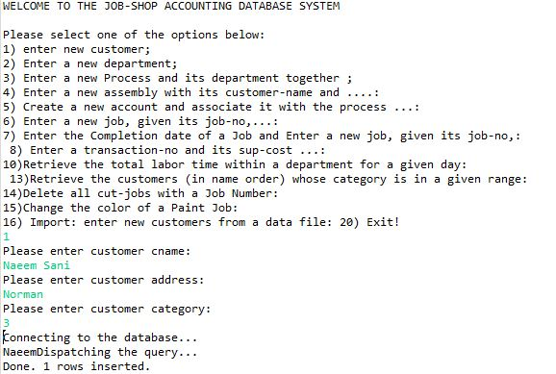

After 5 Run for query number 1.

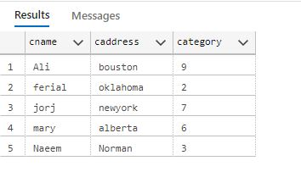

6.2

Query 2:

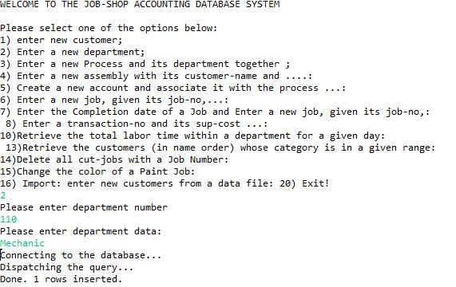

After 5 run for query 2

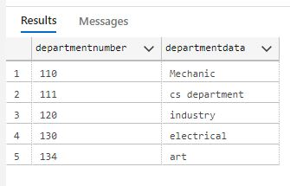

6.3

10 query for type 3.

Process table :

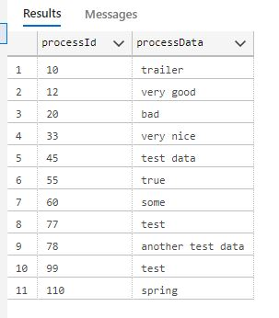

Cut table:

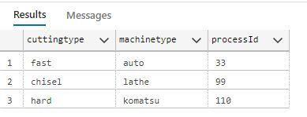

Paint table:

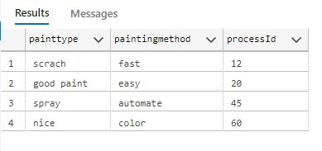

Fit table:

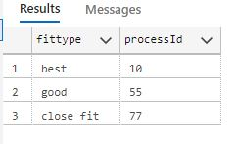

Supervise table:

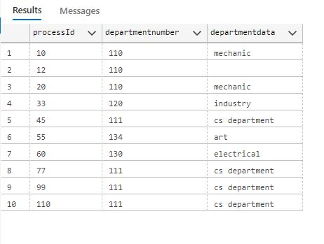

6.4.

10 query for type 4.

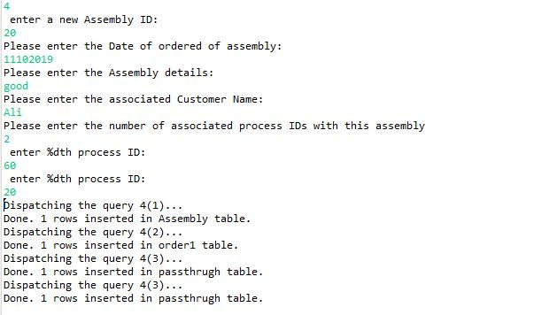

Assembly Table

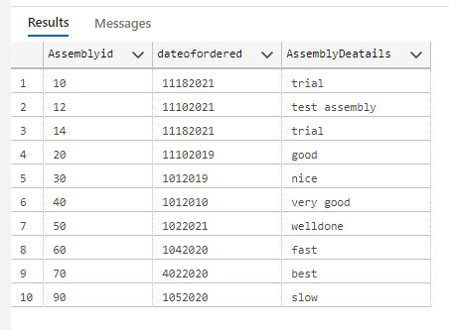

Order1 Table:

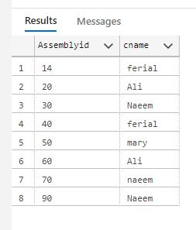

Pass-through Table:

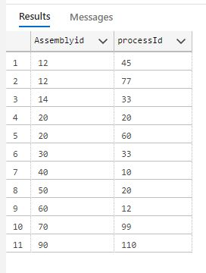

6.5.

10 query for type 5.

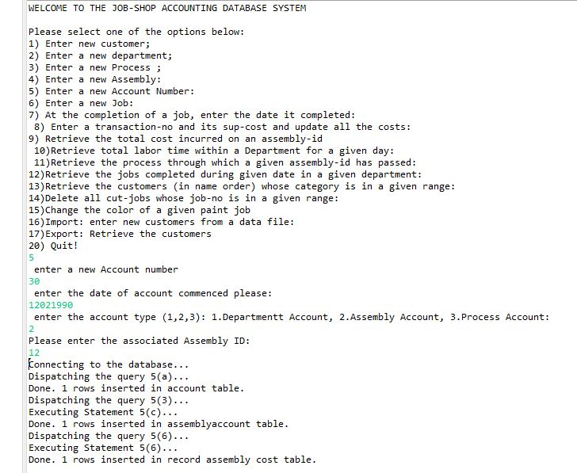

Account Table:

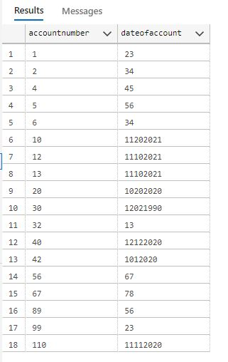

Process account table:

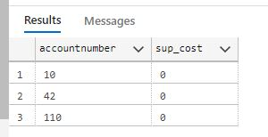

Department account table:

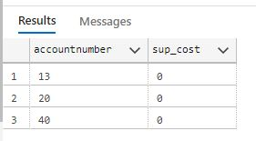

Assembly account table:

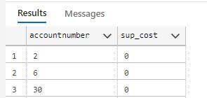

6.6.

10 query for type 6.

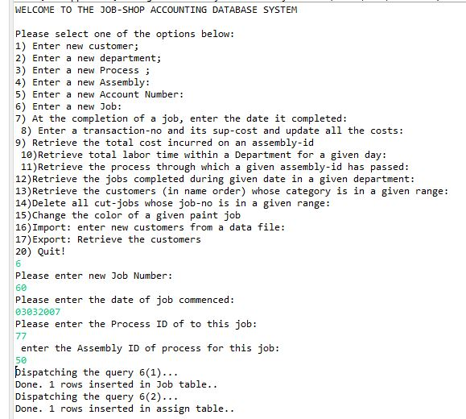

Job Table

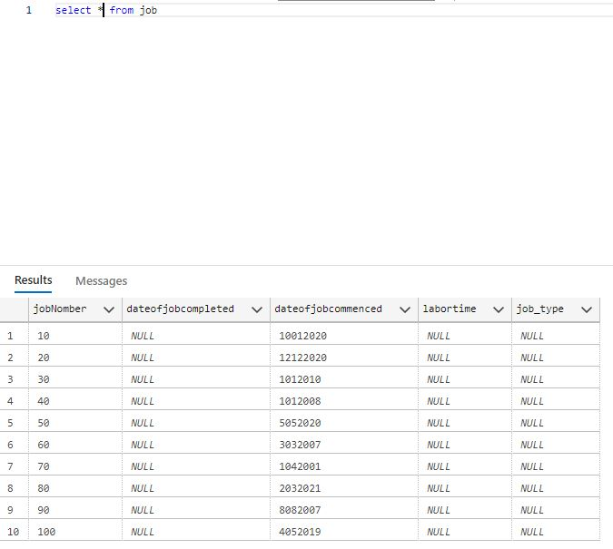

Assign Table:

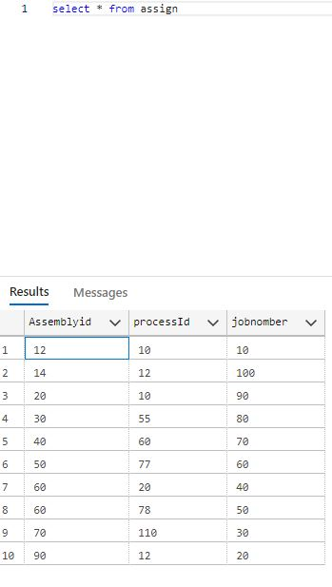

6.7.

10 query for type 7.

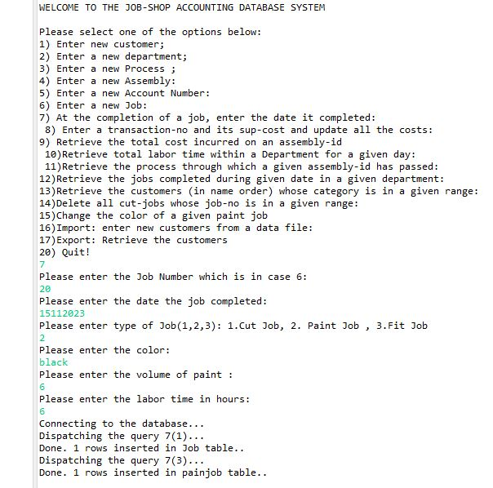

Job table:

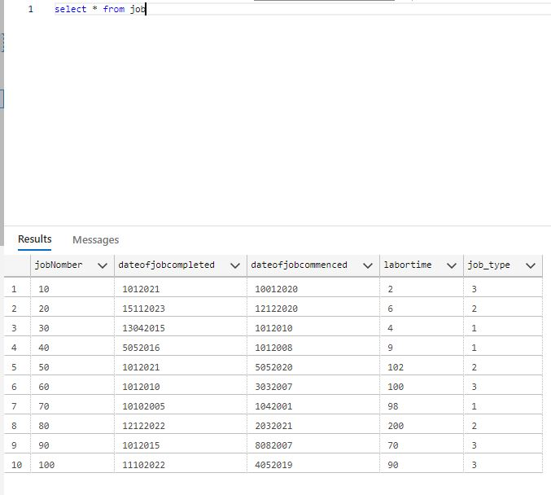

Cut job Table:

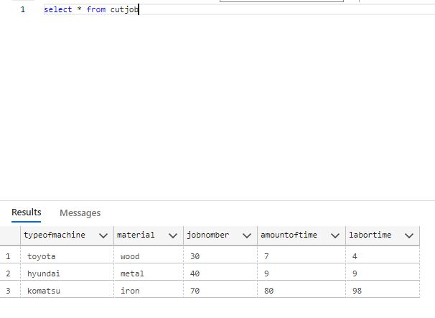

Paintjob Table:

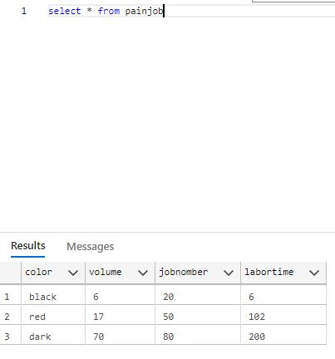

Fit job table:

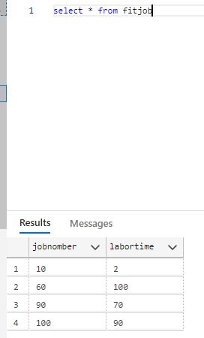

6.8

6.9.

6.10

3 query for type 10:

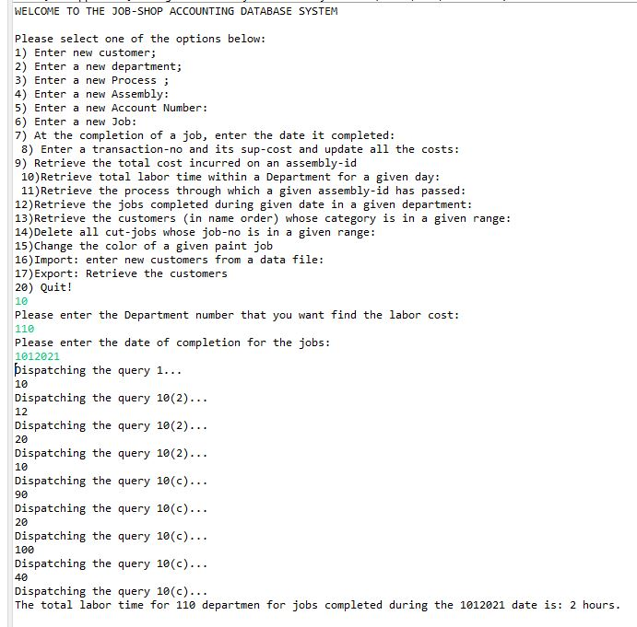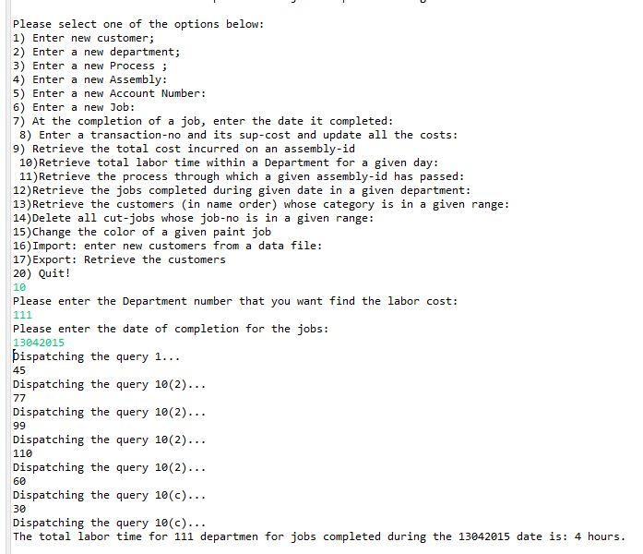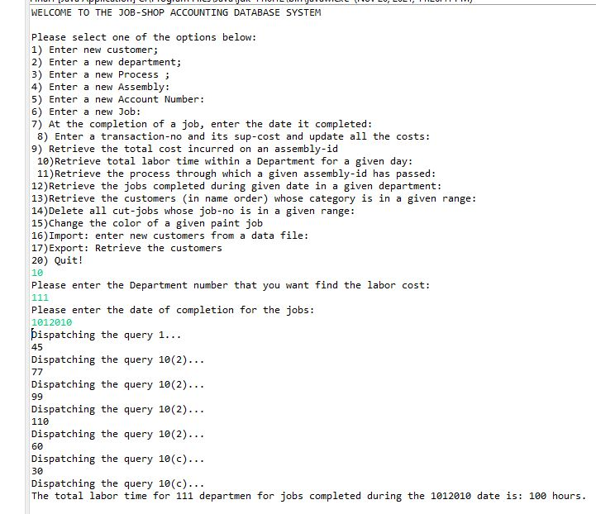

6.11.

3 query for type 11:

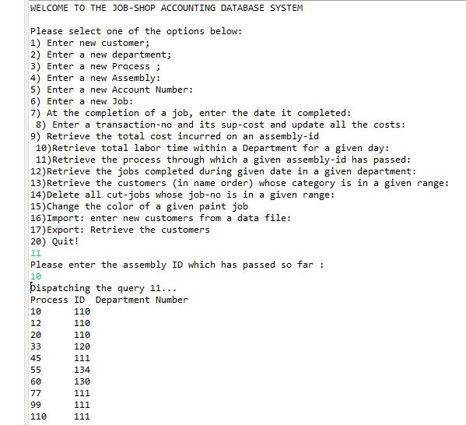

6.12.

3 query for type 12:

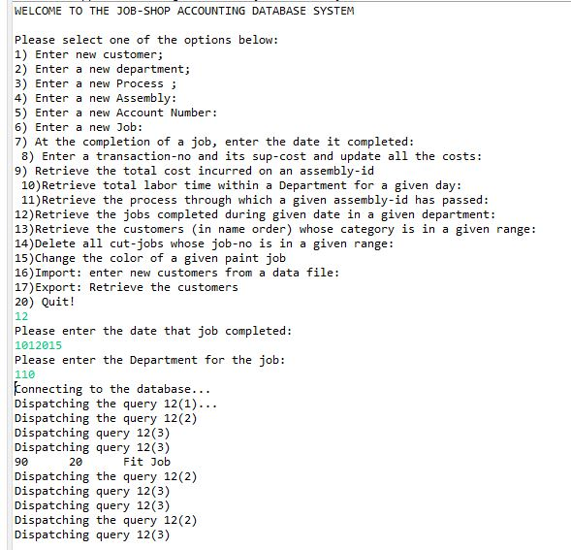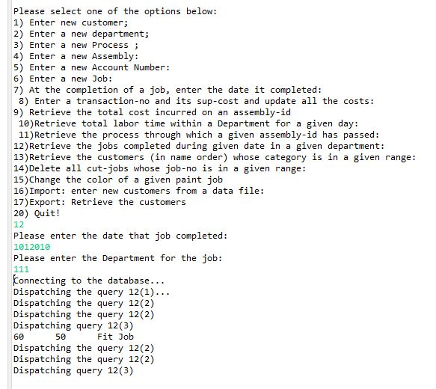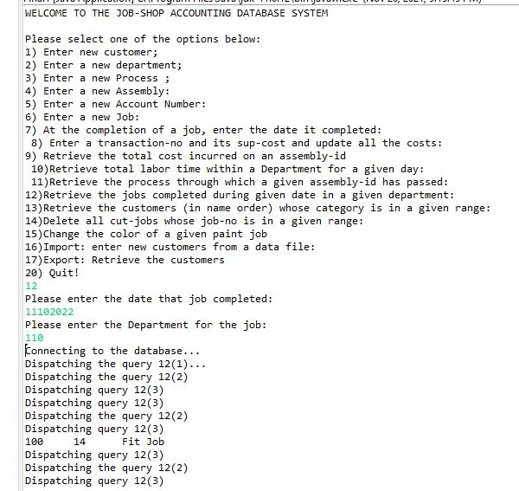

6.13.

3 query for type 13:

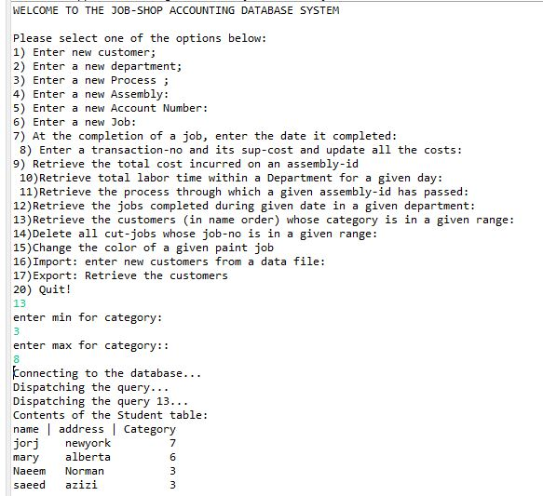

Run 2:

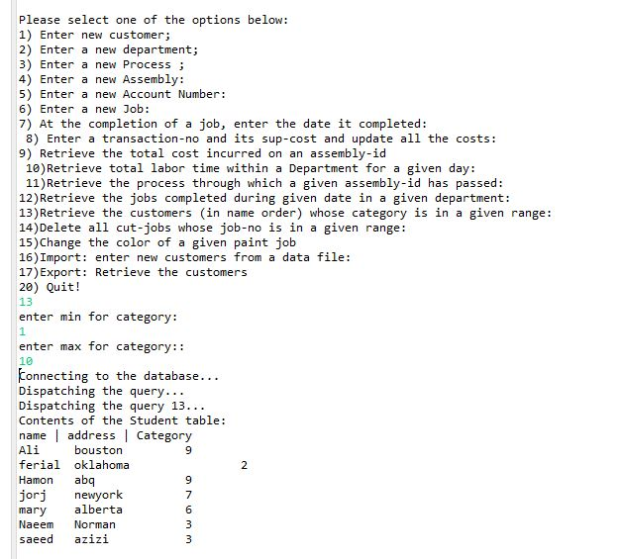

Run 3:

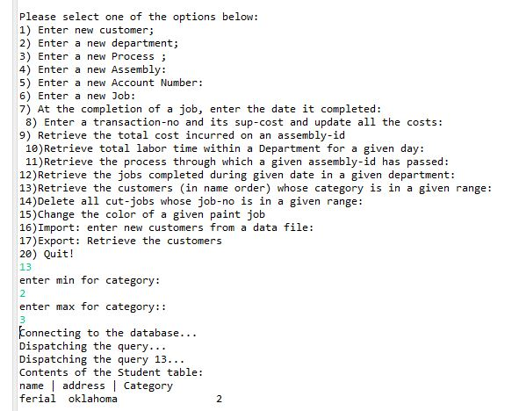

6.14.

3 query for 14:

This is a cut job table before run:

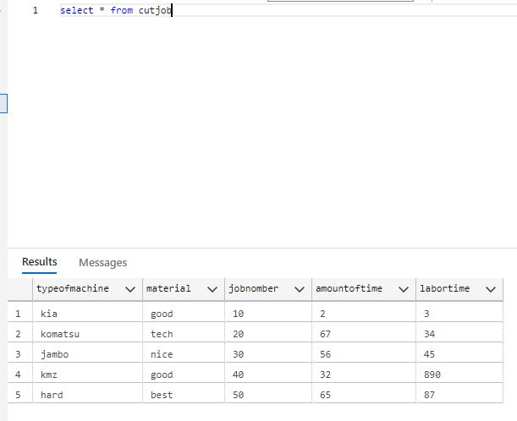

Run 1:

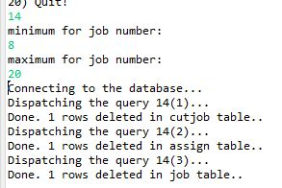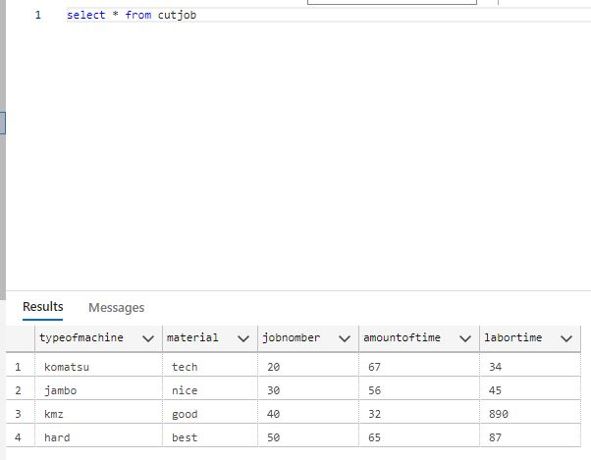

Run 2:

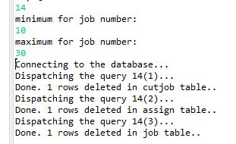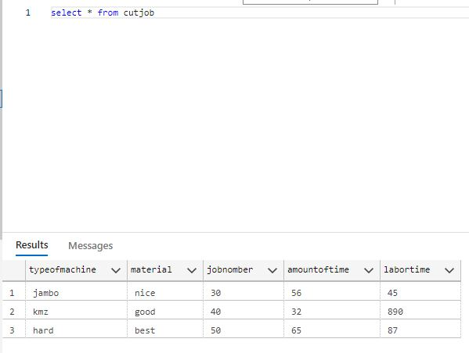

Run 3:

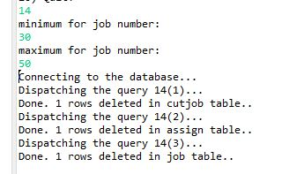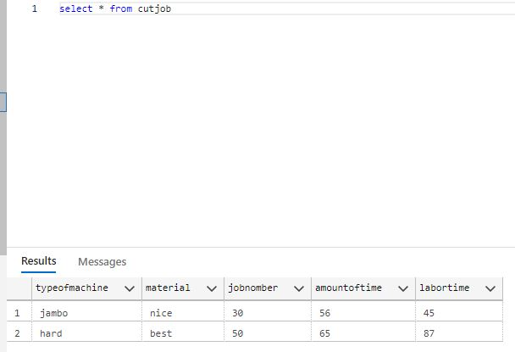

6.15.

3 query for 15:

This is paintjob table before run.

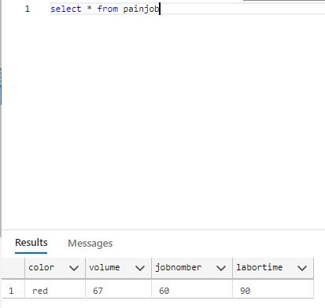

Run 1:

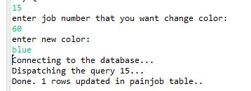

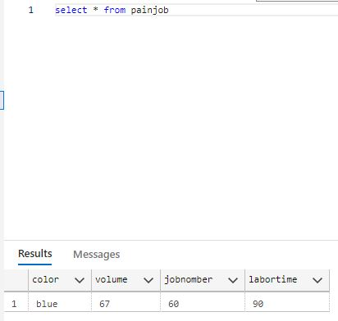

Run 2:

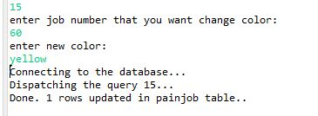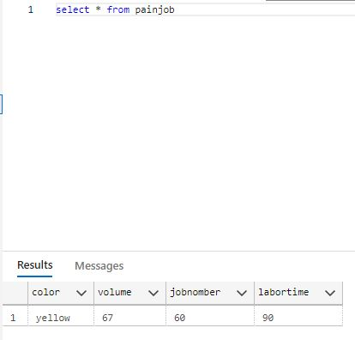

Run 3:

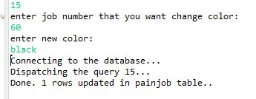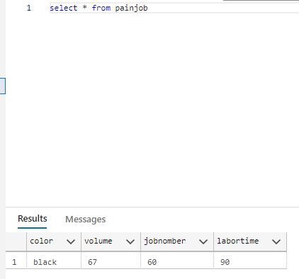

6.16.

1 run for query 16:

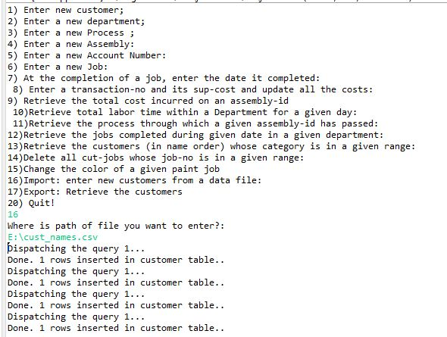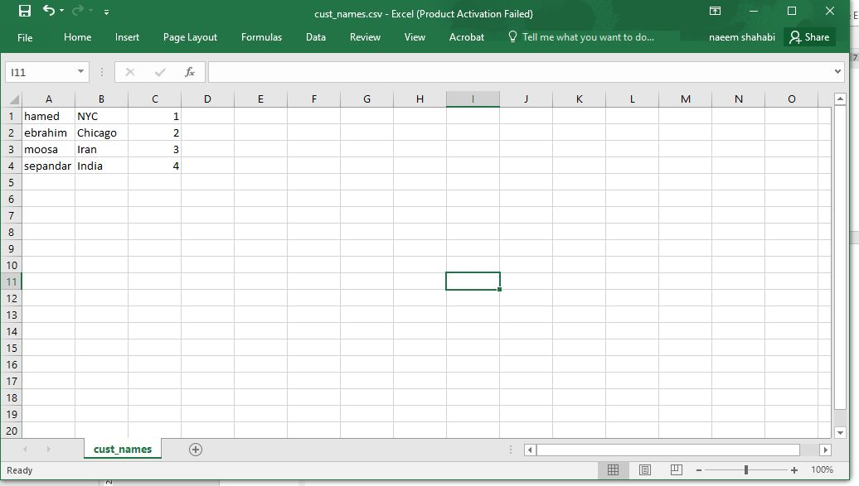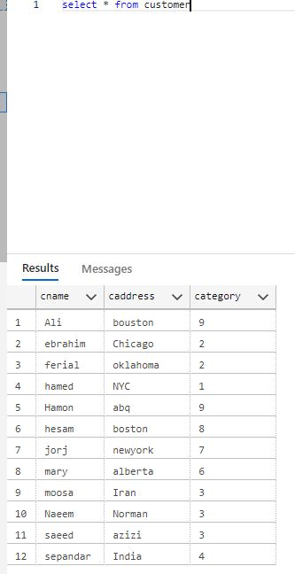

6.16.

1 run for query 17:

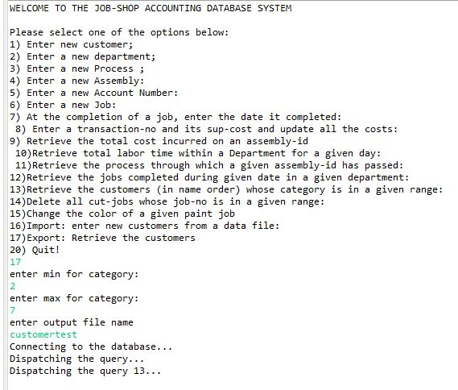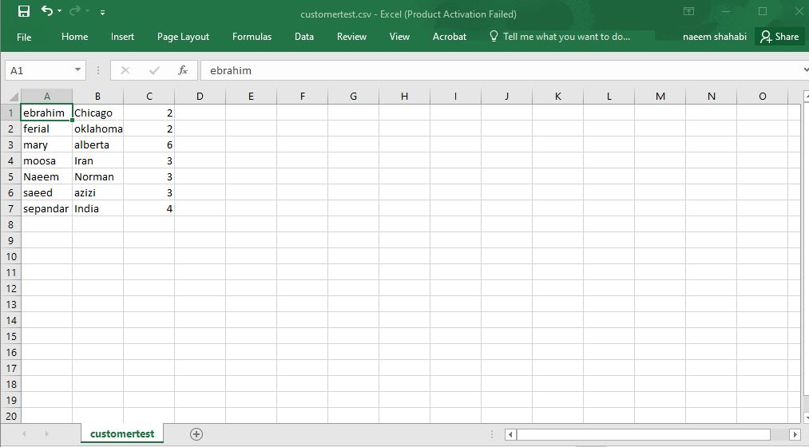

6.17.

Error checking.

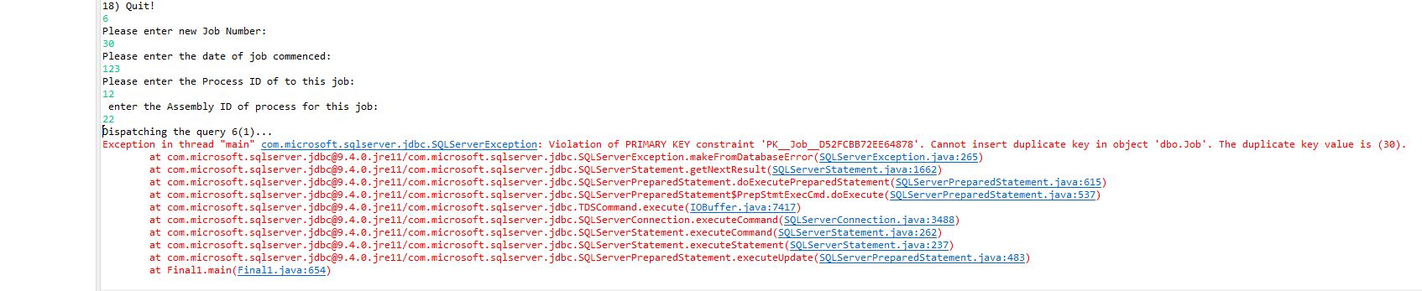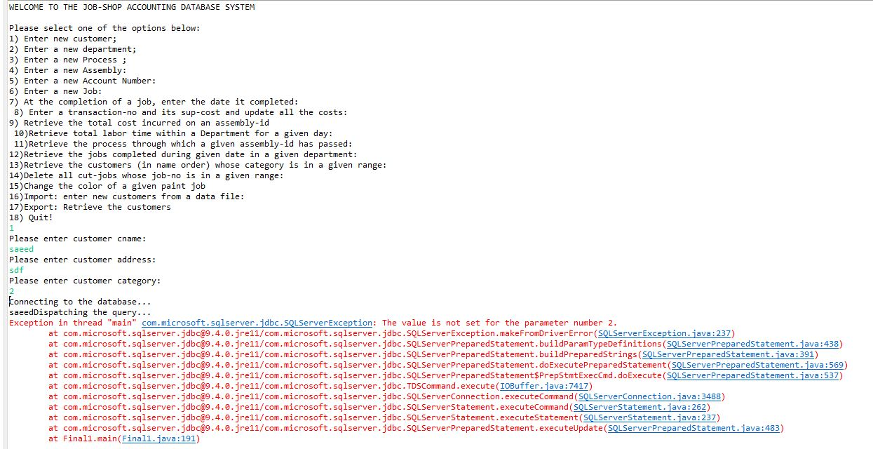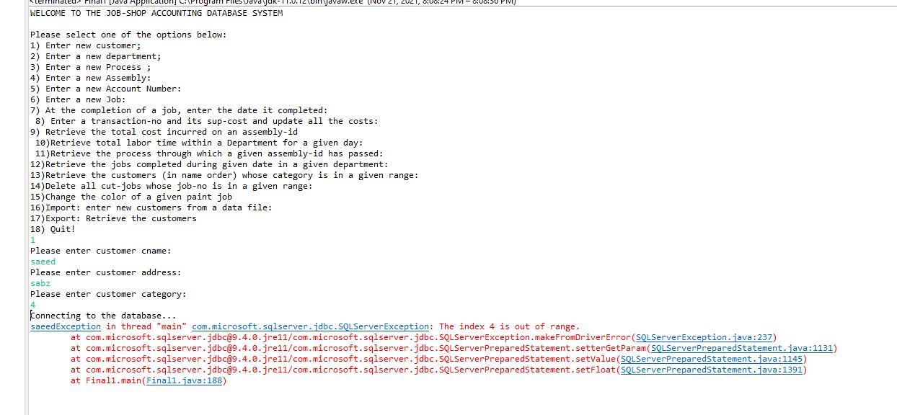

Also errors in Azure SQL:

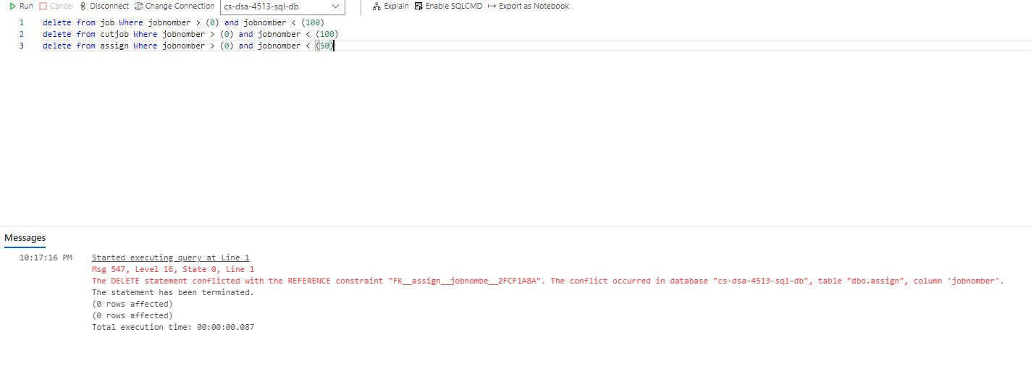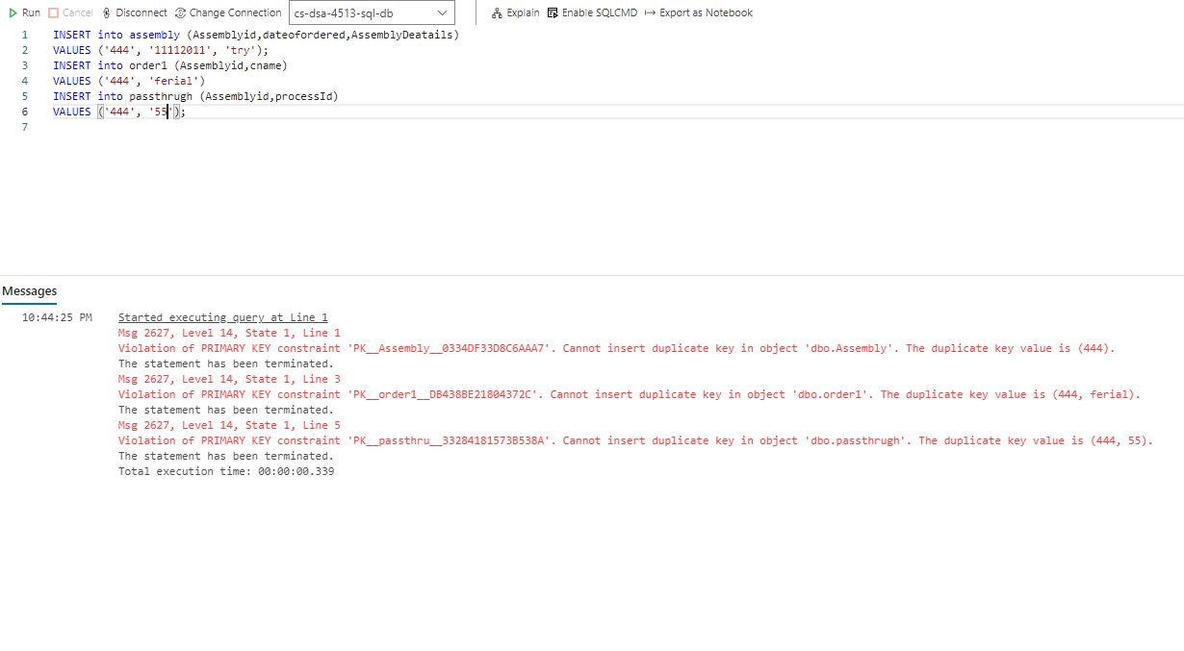

6.18.

Run query 18:

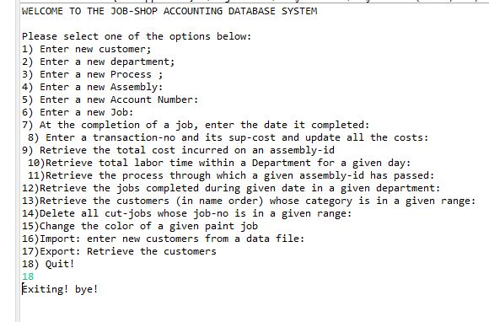

Question 7:

**7.1. Web database application source program and screenshots**

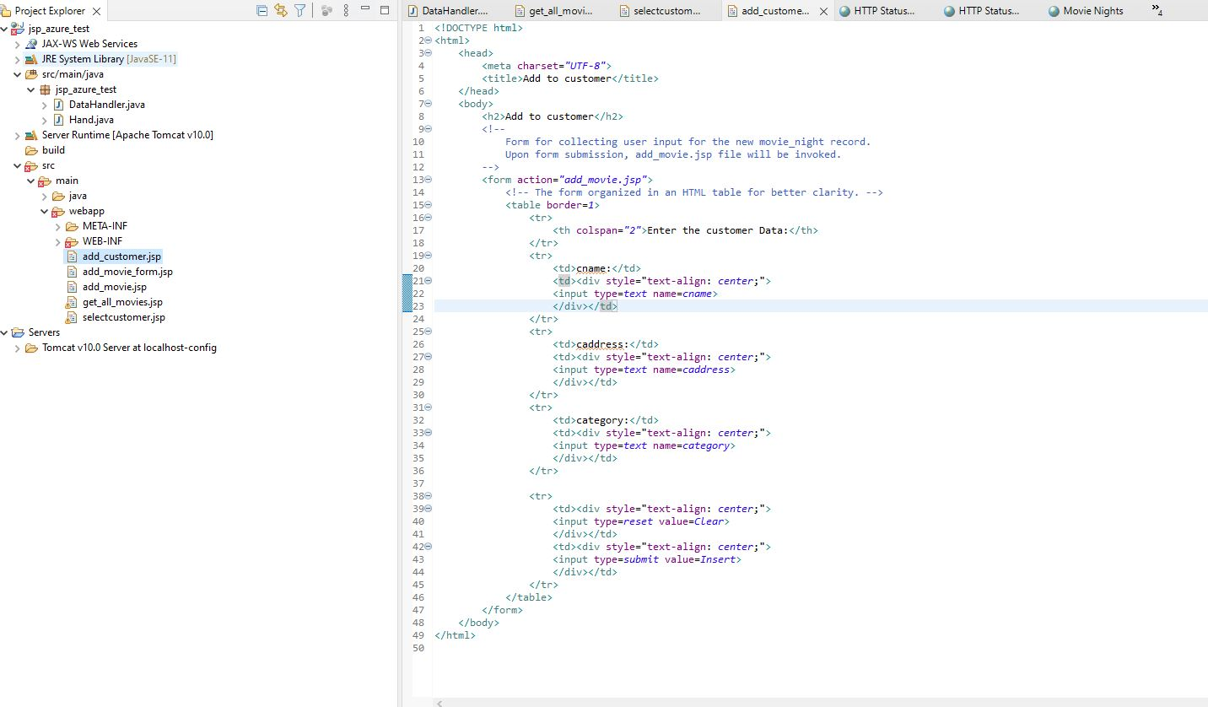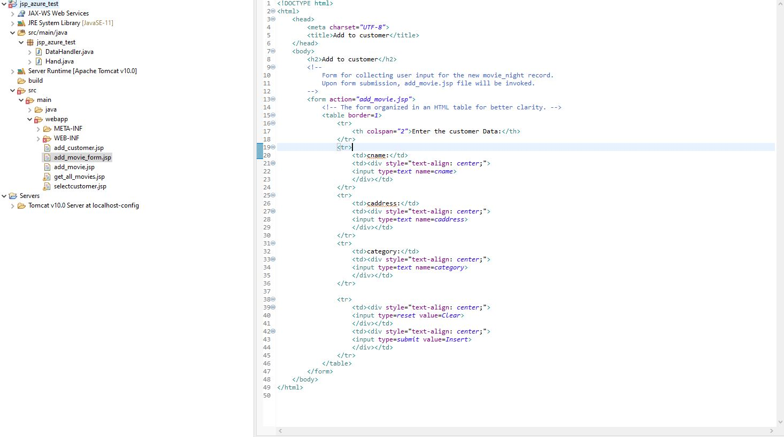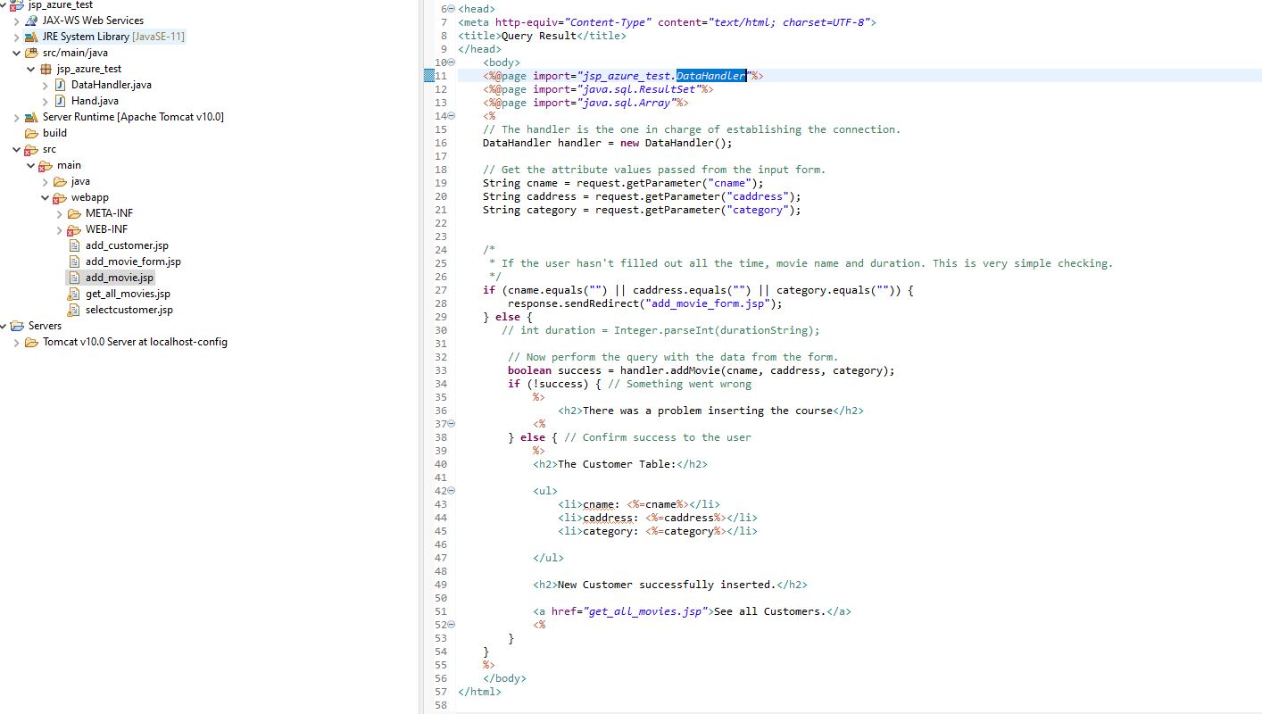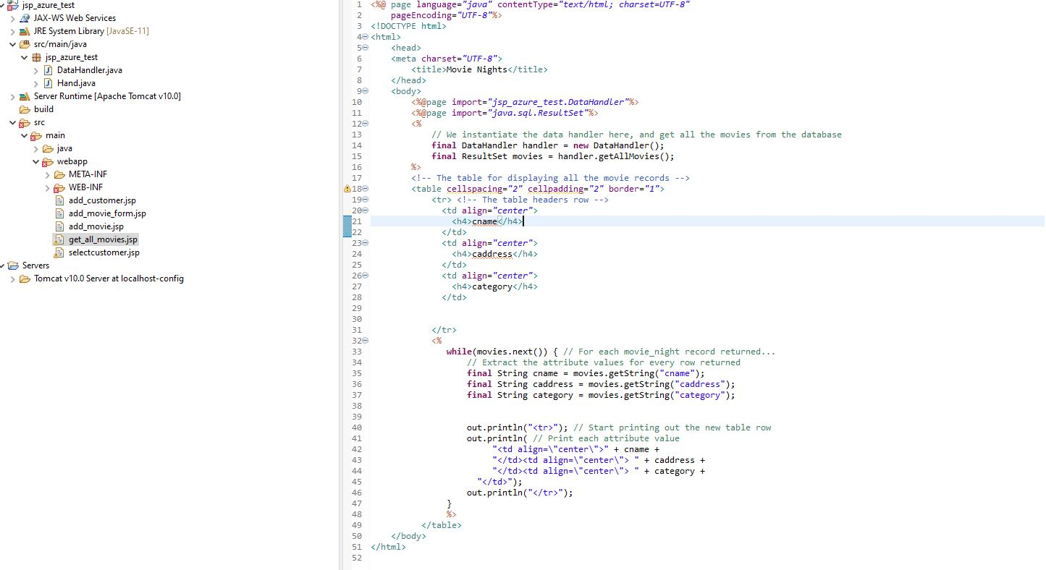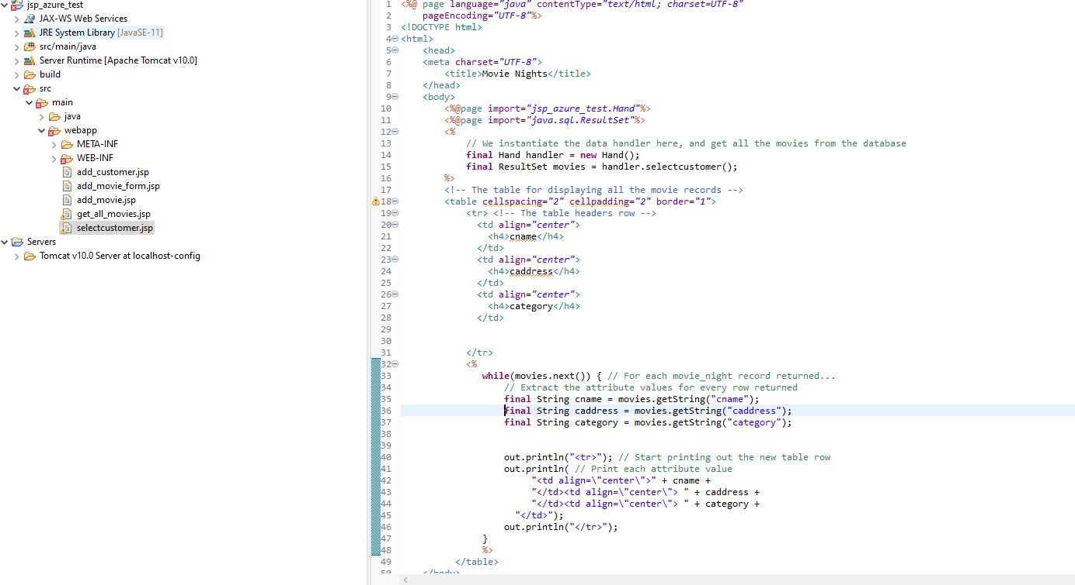

**7.2 Screenshots showing the testing of the Web database application**

Get_all_movies.jsp: Show all the customers in customer table.

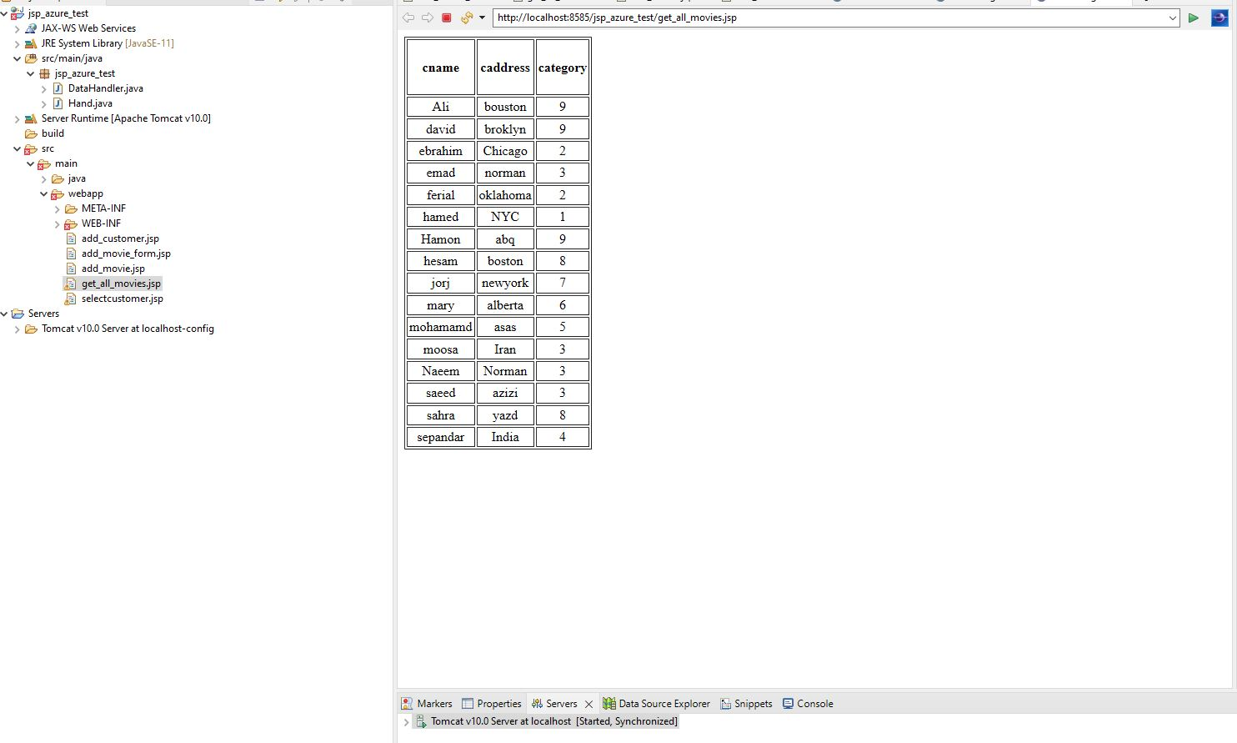

.

Run the program in this order : first query 13 then query 1 and then 13 again.

First run 13 for period between 5, 10.

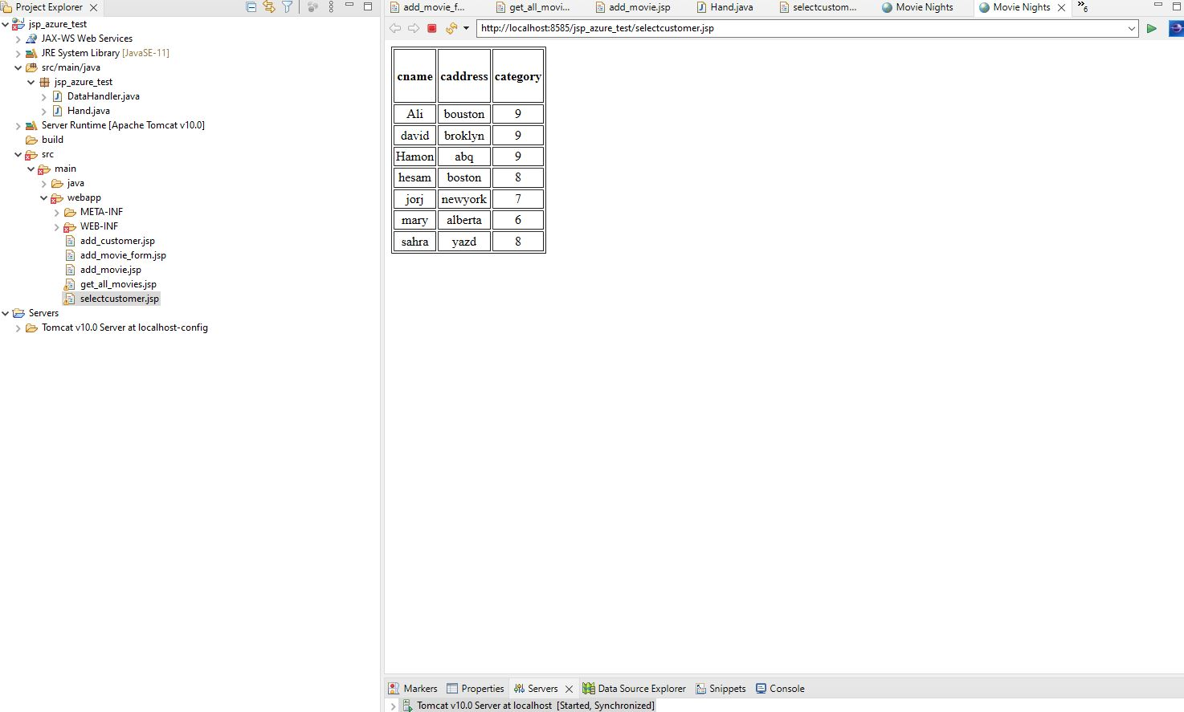

Run 1 and add new customer with category 7

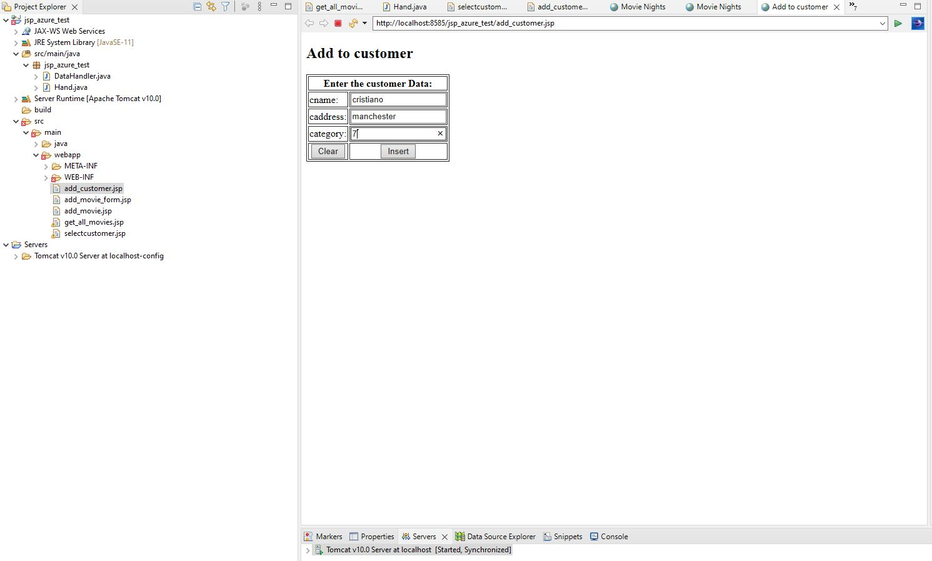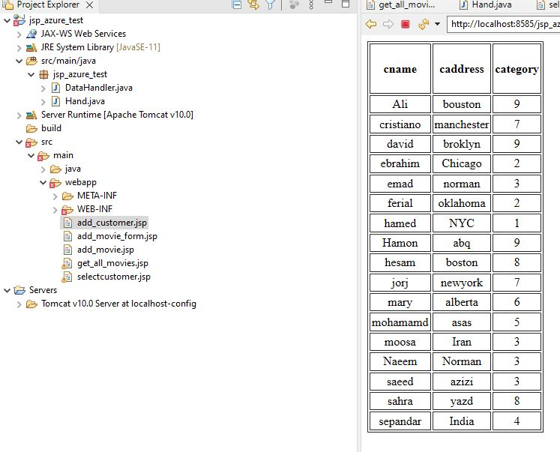

Run Query 13 again for period between 6 and 9.

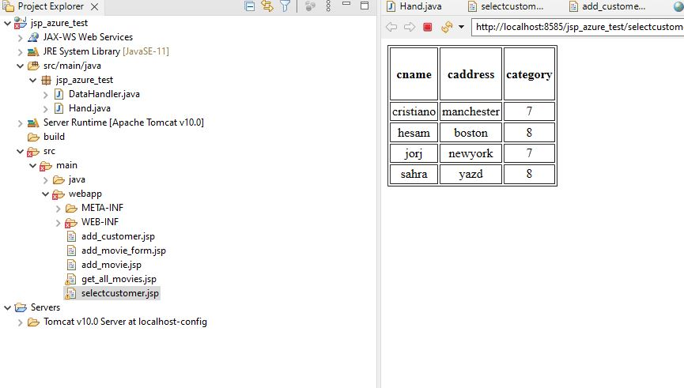

As you can see the result of query 1 change the result of query 13.